
Requirement & Design Specification
HotelHub Management System
GROUP 2
SE1919-NJ
Lê Trần Trọng Đạt - HE 194235
Võ Hoàng Phúc - HE 186974
Dương Trọng Lực - HE 187000
Trần Đình Huy - HE 171917
Phạm Nguyên - HE 182242
Lecturer : Nguyen Cuong Manh
Version: 1.0
– Hanoi, March 2025 –

Record of Changes

Date | A*  M, D | In charge | Change Description
18/7/2025 | M | HuyTD | II. Function Requirement
15/7/2025 | M | PhucVH | II. Function Requirement
22/7/2025 | M | LucDT | III. System design
20/7/2025 | M | HuyTD | I.1 Context Diagram
17/7/2025 | M | DatLTT | I.2.3 Use Case Diagram(s)
18/7/2025 | M | DatLTT | III.2 Code Packages
18/7/2025 | M | DatLTT | I.4 Overall Functionalities

Contents
I. Overview
- System Context
- User Requirements
  - Introduction
  - Actors
  - Use Case Diagram(s)
    - UCs for Guest
    - UCs for Customer
    - UCs for Receptionist
    - UCs for Manager
    - Description
- Main Workflows
3.1 Log In
3.2 Registration
3.3 Booking Room
3.4 Manage User
3.5 Manage Room
- Overall Functionalities
4.1 Screens Flow
4.2 Screen Descriptions
4.3 Screen Authorization
4.4 Non-UI Functions
II. Functional Requirements
- Customer
1.1 HomePage
1.2 User Login
1.3 Register
1.4 Forgot Password
1.5 User Profile
1.6 Contact us
1.7 Booking Room Online
1.8 Payment
1.9 Service
1.10 Feedback
- manager
2.1 Show Available Room
2.2 Manage Blog
2.3 Manage Room
2.4 Manage Invoice
2.5 Manage Account
2.6 Manage Service
2.7 Manage Booking
2.8 Manage Feedback
2.9 Manage Promotion
2.10 Payment Page

III. System Design
- Database Design
1.1 Entity-Relationship Diagram
1.2 Table Descriptions

I. Overview

1.Context Diagram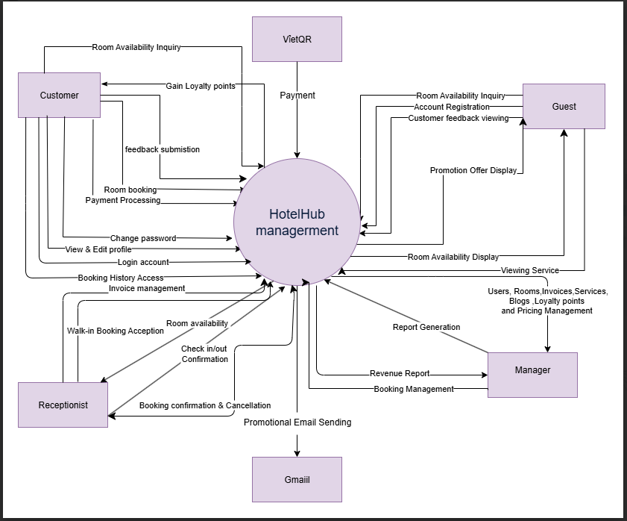
Figure 1.1 Context Diagram

2. User Requirements

2.1 Introduction
A Hotel Management System (HUB) is a comprehensive platform designed to streamline hotel operations, enhance guest experiences, and improve efficiency in managing accommodations. This system provides a wide range of features to support hotel operations, from room reservations, guest check-in/check-out, and housekeeping management to billing and reporting.

2.2 Actors

ID | Actor | Description
1 | Guest | A non-registered user who can browse room availability, view promotions, and register an account.
2 | Customer | A registered user who can book rooms, manage bookings, process payments, and submit feedback.
3 | Receptionist | Manages check-ins, check-outs, booking confirmations, and onsite payments.
4 | Manager | Oversees booking management, room pricing, revenue reports, and promotional campaigns.
5 | VietQR (Payment Gateway) | Handles secure online payment processing for bookings.
6 | Gmail (Email  System) | Sends feedback email, contact email

2.3 Use Case Diagram(s)

a. UCs for Guest

b. UCs for Customer

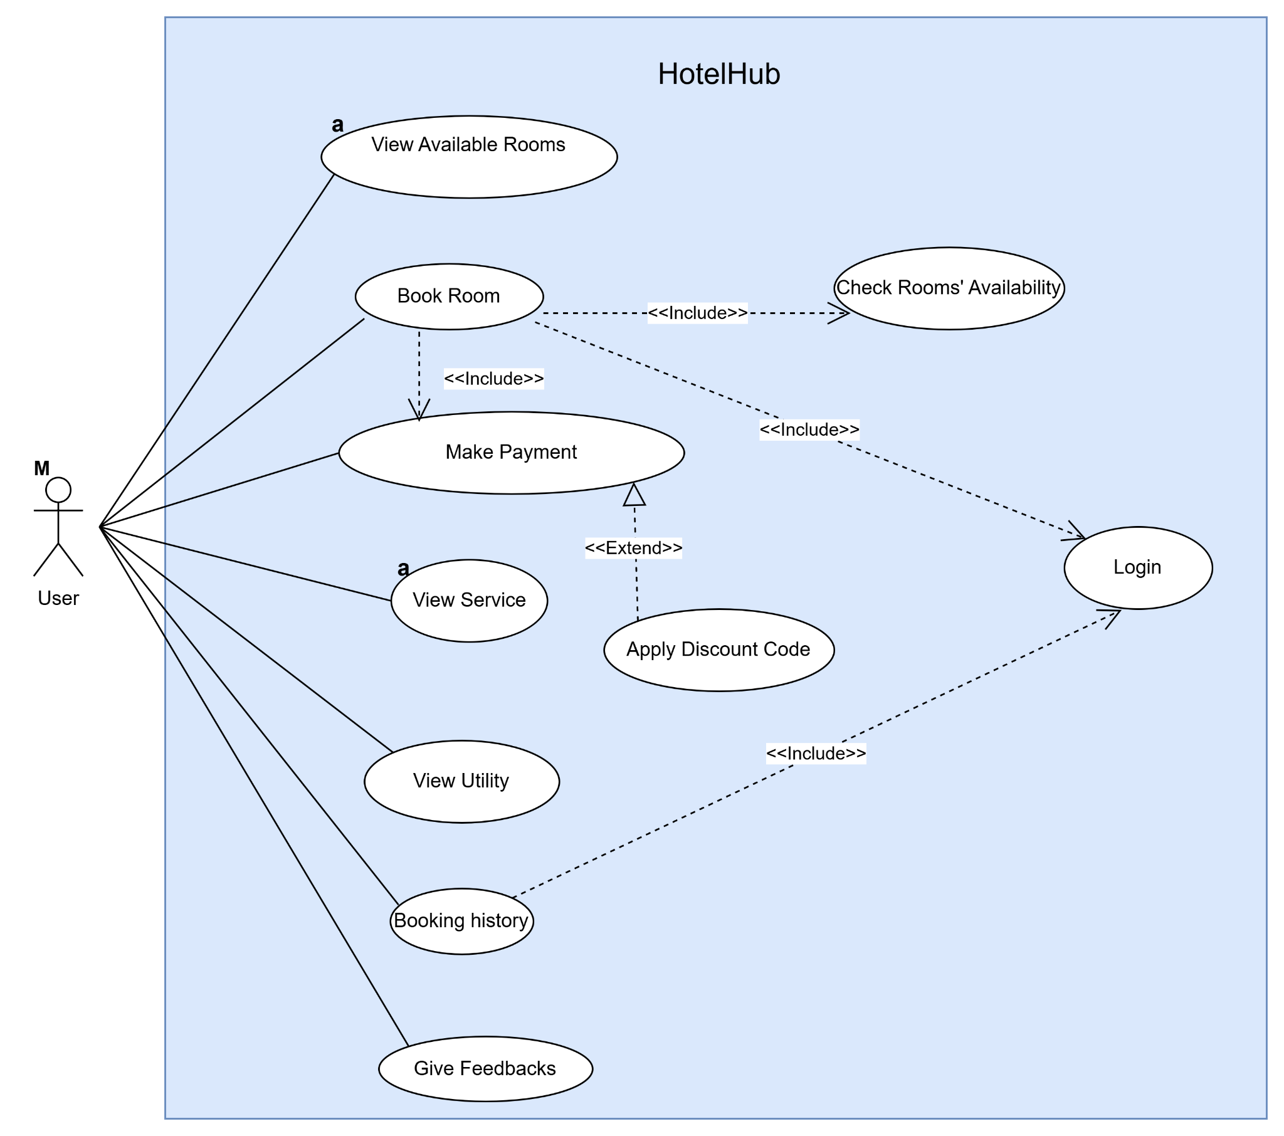

c. UCs for Receptionist
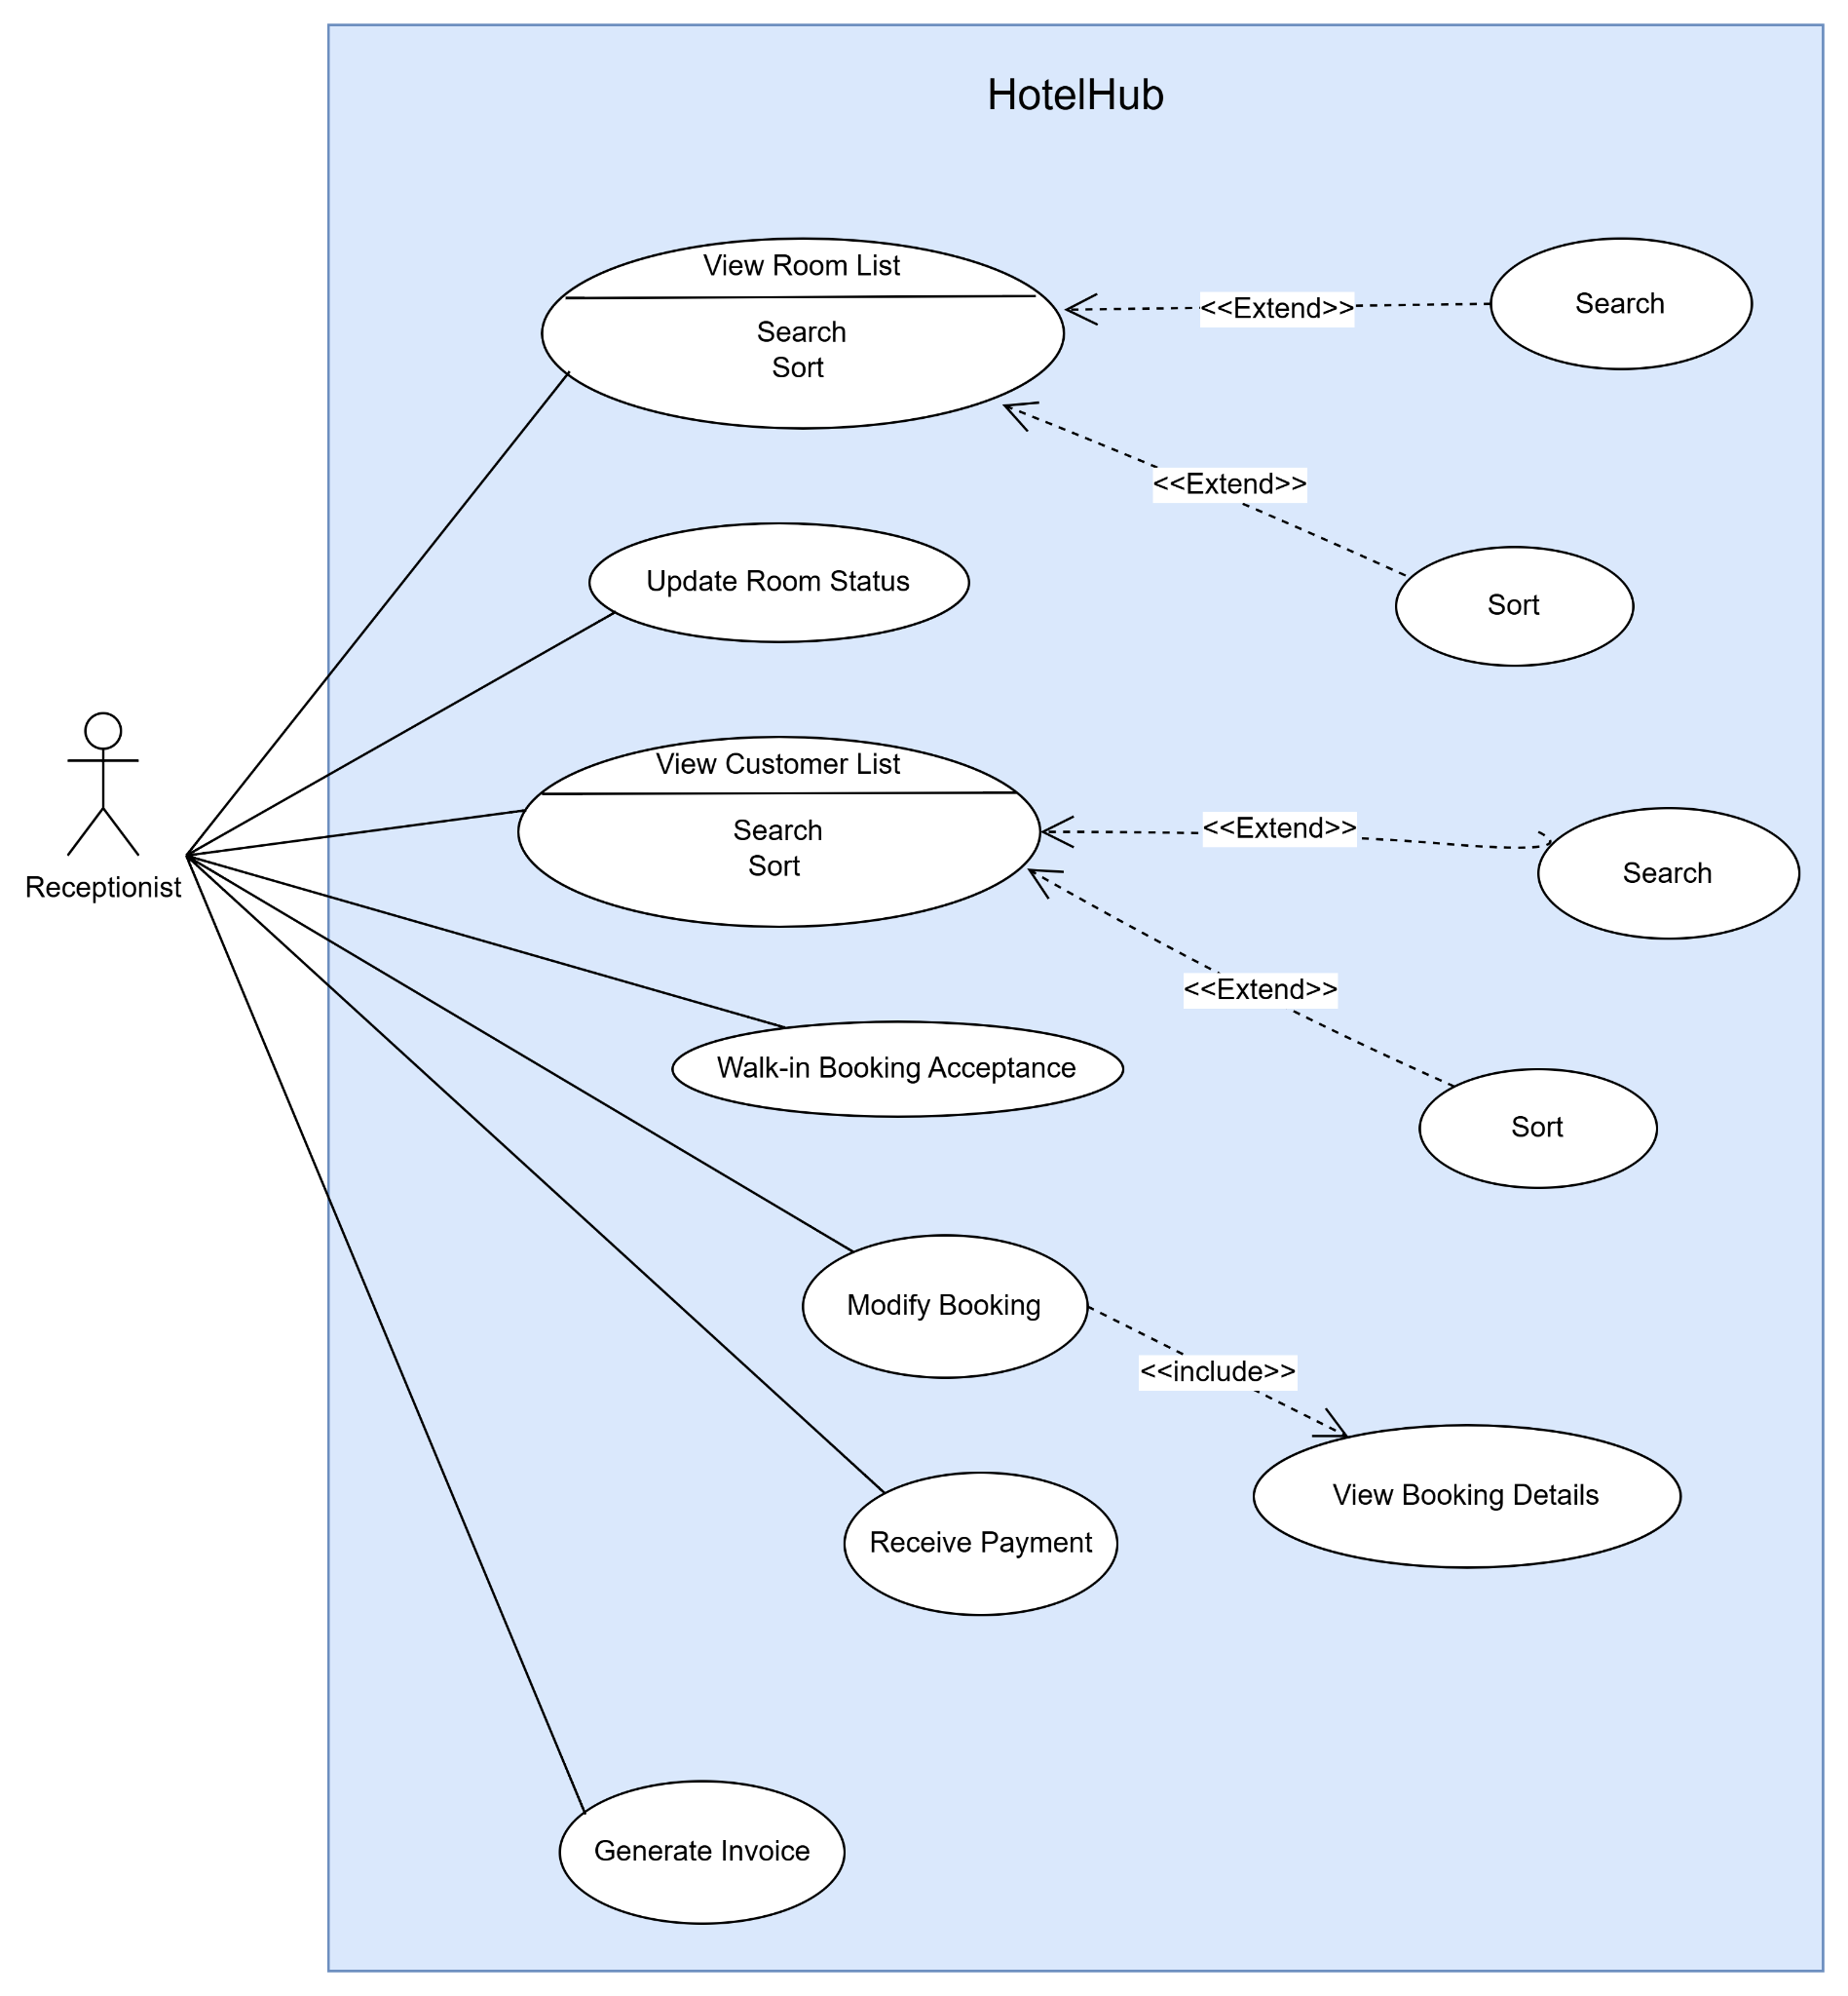

d. UCs for Manager
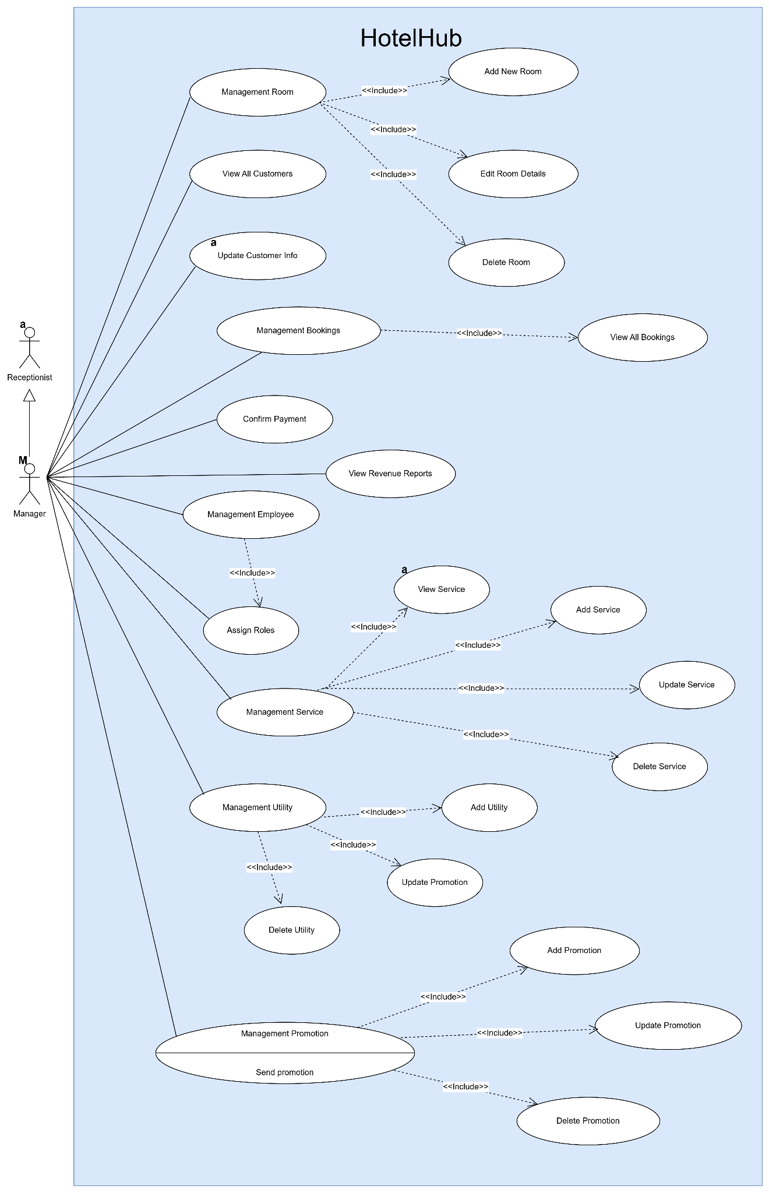

e. Descriptions
ID | Feature | Author | Use Case | Description
UC1 | Room Management |  | View Available Rooms | Allows users to view a list of available rooms in the hotel.
UC2 | Room Management |  | View Room  Details | Displays detailed information about a specific room, including price and images.
UC3 | User Management |  | Register Account | Users can create a new account by email / user name to access the system.
UC5 | User Management |  | View Service | Users can view a list of services provided by the hotel.
UC6 | User Management |  | Log in | Allows users to log into the system using their registered account credentials.
UC7 | User Management |  | Register | New users can create an account to access system features.
UC8 | User Management |  | Forgot password | This use case describes the process by which a user who has forgotten their password can request a One-Time Password (OTP) to reset it. The OTP can be sent via email or SMS.
UC9 | User Profile |  | View Profile | Users can view their personal information after logging in.
UC10 | User Profile |  | Edit Profile | Users can edit personal  information such as name, phone number, and address.
UC11 | User Profile |  | Change Password | Users can change their account password for better security.
UC12 | Booking Management |  | Book Room | Allows customers to book a room. Includes checking room availability.
UC13 | Booking Management |  | Check Room  Availability | Ensures that the selected room is available before booking.
UC14 | Booking Management |  | Cancel Booking | Allows customers to cancel a previously made room booking. Includes making a refund if applicable.
UC15 | Payment Management |  | Make Payment | Enables customers to make a payment for their booking or services.
UC16 | Payment Management |  | Apply Discount Code | Allows customers to apply a discount code during payment. This is an extension point for the

 |  |  |  | "Make Payment" use case.
UC17 | Service Management |  | Request Service | Allows customers to request a specific service. Includes checking service availability.
UC18 | Service Management |  | Check Service  Availability | Ensures that the requested service is available before confirmation.
UC19 | Service Management |  | Payment for  Services | Customers can make payments for additional services  requested.
UC20 | Room Management |  | View Room List | Allows the receptionist to view a list of all rooms in the hotel.
UC21 | Room Management |  | Update Room  Status | Enables the receptionist to update the status of rooms
UC22 | Customer Management |  | View Customer List | Allows the receptionist to view a list of all registered customers.
UC23 | Customer Management |  | Update Customer Info | Enables the receptionist to update customer details such as contact information (booking offline).
UC24 | Booking Management |  | Create Booking | Allows the receptionist to create a new booking for a customer (booking offline).
UC25 | Booking Management |  | Modify Booking | Enables the receptionist to modify existing bookings, including changing room details or dates. Includes viewing booking details.
UC26 | Booking Management |  | View Booking  Details | Allows the receptionist to view detailed information about a specific booking.
UC27 | Room Management |  | Add New Room | Allows the manager to add a new room to the system.
UC28 | Room Management |  |  | Edit Room D Details Enables the manager to modify the details of an existing room.
UC29 | Room Management |  | Delete Room | Allows the manager to remove a room from the system.
UC30 | Room Management |  |  | View All Bookings Enables the manager to see all room bookings.
UC31 | Booking Management |  | Confirm Payment | Enables the manager to confirm payments for bookings or services.
UC32 | Reporting |  | View Revenue  Reports | Allows the manager to generate and view revenue-related

 |  |  |  | reports.
UC33 | Employee Management |  | Assign Roles | Enables the manager to assign specific roles to employees.
UC34 | Service Management |  | View Service | Allows the manager to view the list of services offered by the hotel.
UC35 | Service Management |  | Add Service | Enables the manager to add new services to the system.
UC36 | Service Management |  | Update Service | Allows the manager to modify existing services.
UC37 | Service Management |  | Delete Service | Enables the manager to remove a service from the system.
UC38 | Amenity Management |  | Add Amenity | Allows the manager to add amenities to the system.
UC39 | Amenity Management |  | Update Amenity | Enables the manager to update details of an amenity.
UC40 | Amenity Management |  | Delete Amenity | Allows the manager to remove an amenity from the system.
UC41 | Promotion Management |  | Add Promotion | Enables the manager to create promotional offers.
UC42 | Promotion Management |  | Update Promotion | Allows the manager to update promotional details.
UC43 | Promotion Management |  | Change status Promotion | Allows the manager to change status promotion
UC44 | Promotion Management |  | Delete Promotion | Enables the manager to remove a promotion from the system.
UC45 | Booking history |  | View Booking  history | Allow users (customers) to view their past bookings.
UC46 | Pointer manager |  | Increase pointer | Customer can get pointer after booking online
UC47 | Feedback of customer |  | Submit feedback | Allow customers to submit feedback after their stay.
UC48 | Feedback Manager
UC49 | Manage Booking list |  |  | check-in/ check-out Allow customers to submit feedback after their stay.
UC50 | Manager blog |  | Create blog | Admin create/ update Blog

3. Main workflows

3.1 Log in
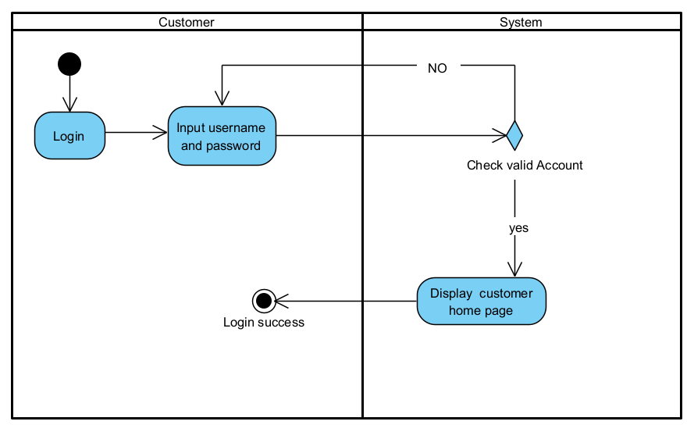

3.2 Registration
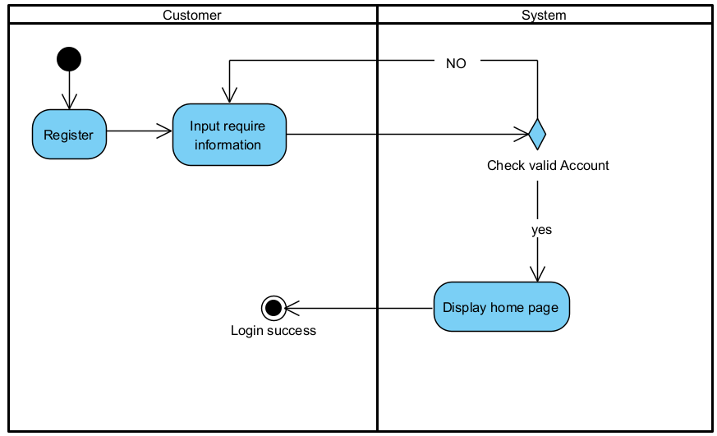

3.3 Booking room
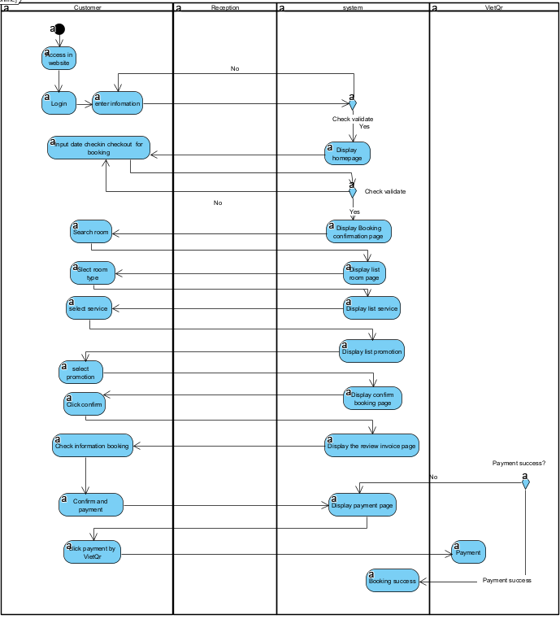

3.4 Manage User
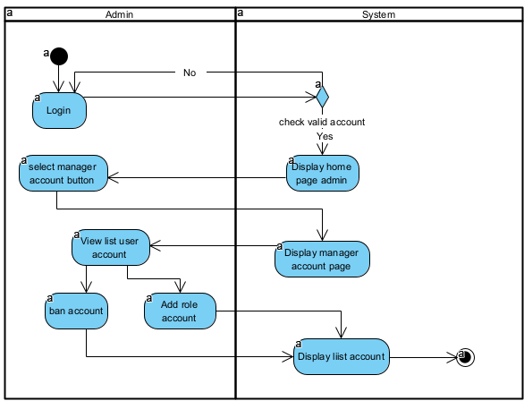

3.5 Manage room
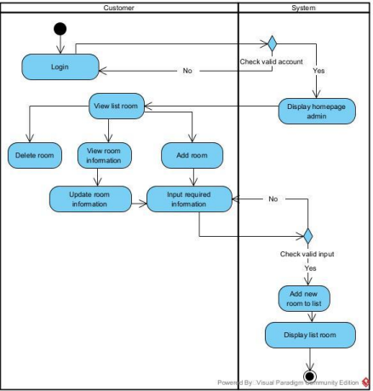

4. Overall Functionalities

4.1 Screens Flow
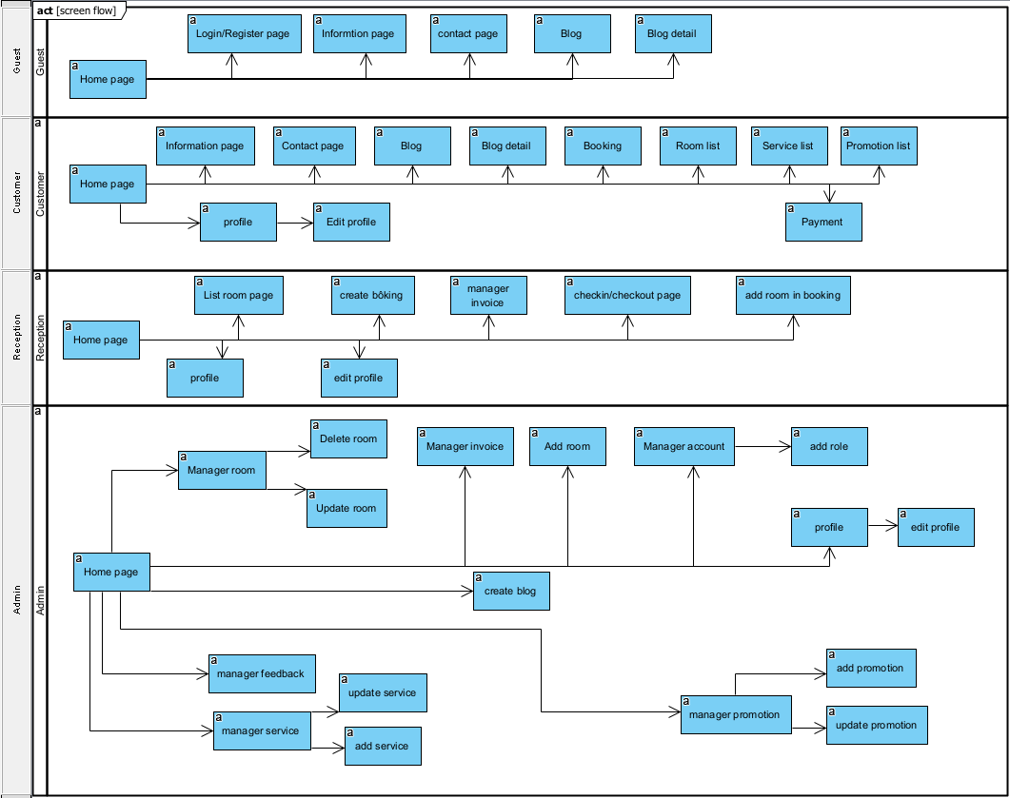

4.2 Screen Descriptions

ID | Feature |  | Description
1 | Home Page | Home Page | Main landing page for all users.
2 | Authentication | Login | Allows users to log into their accounts.
3 | Authentication | Register | Enables new users to create an account.
4 | Information | Information page | Provide hotel details to users.
5 | Contact | Contact page | Enables users to get in touch or seek support.
6 | Blog | Blog | Displays blog posts for users to read.
7 | Blog Detail | Blog detail | Shows detailed content of a specific blog post.
 | Booking | Booking | Allows users to make or manage bookings.
 | Room List | Room List | Lists available rooms for users to select.

4.3 Screen Authorization
Feature | Customer | Receptionist | Admin
Home Page | X | X | X
Log in/log out | X | X | X
Room Details | X | X | X
Room | X | X | X
Room Type |  | X | X
Booking | X | X
Payment Gateway | X
Payment Success/ Payment | X |  | X
Revenue Report |  |  | X
Profile Management | X |  | X
Contact | X |  | X
Password Reset | X |  | X
Service | X | X | X
Blog | X | X | X
Feedback | X
Check-in/Checkout |  | X | X
User Management |  |  | X
Promotion |  |  | X
Service Statistics |  |  | X

4.4 Non-UI Functions

ID | Feature | System Function | Description
1 | Authentication | Login, register, forgot password | - check if username or email is duplicate  - check if password and password confirmation match when registering  - send OTP to email/phone number when forgot
2 | Booking System | calculate price when booking | Calculate total cost for users based on selected rooms, services, and apply promotions if available.
3 | Booking System | get room, service, promotion data | Retrieve room availability, available services, and current promotions from the database.
4 | Chat AI | User submits  questions about the hotel | To provide automated, real time conversational  assistance to users for common guidance, or support.

II. Functional Requirements

1. Customer

1.1 HomePage

1.1.1 Screen Design
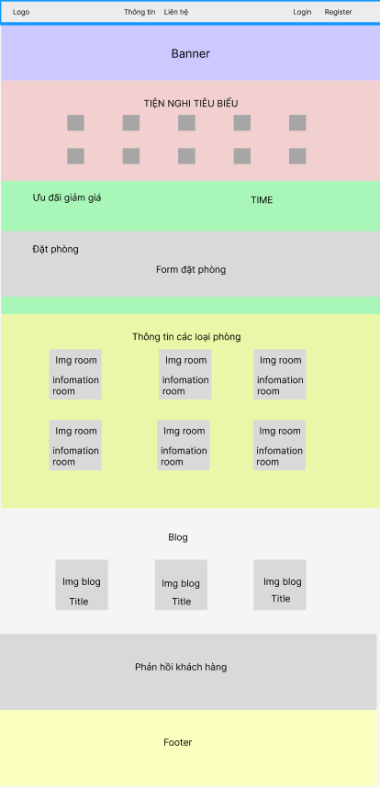

# | Field Name | Type | Mandatory | Max  Length | Description
1 | banner | image
2 | amenity | image |  |  | Amenity of holtel
3 | Image room | Image |  |  | Display the room image
4 | Image blog | Image |  |  | Display the blog image
5 | Information Room | Text |  |  | Display brief  information about the room
6 | Title | Text |  |  | Display brief  information of the blog
7 | feedback | Text |  |  | Display the Feedback of customer

1.2 User Login

1.1.1 Screen Design
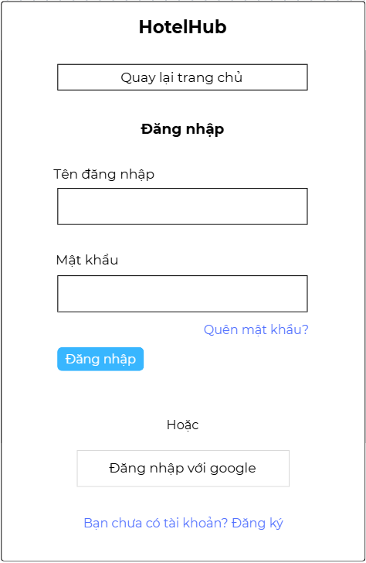

Screen after activation:
# | Field Name | Type | Mandatory | Max  Length | Description
1 | Username | Email | Yes | 50
2 | Password | Password | Yes | 50 | Display "*" instead of clear character
3 | Login | Button |  |  | Go to home page
4 | Sign Up | Button |  |  | Go to Sign Up pop-up
5 | Forgot Password | (Button) |  |  | Go to the forgot  password pop-up

1.2.2 Use Case specification
ID UC and Name: | UC01 - Login
Created By: | Vo Hoang Phuc | Date Created: | 18/6/2025
Primary Actor: | Customer | Secondary Actors: | Admin,Staff
Trigger: | -The user clicks the login button  -User initiates the login process by entering their credentials.
Description: | This use case describes the login process that allows registered users to access the HotelHub system using a valid username and password.
Preconditions: | PRE – 1: The user already has a registered and active account in the system.
Postconditions: | POST – 1: The user is successfully logged in and redirected to the homepage/dashboard.
Normal Flow: | 1.0: Login using username and password  - The user accesses the login page.  - The system displays the login form.  - The user enters a valid username and password.  - The user clicks the "Login" button.  - The system verifies the credentials.  - If valid, the system logs in the user and redirects them to the homepage.
Alternative Flows: | 1.1: Login using Google  - The user clicks “Login with Google.”  - The system redirects to Google's authentication page.  - The user completes the Google login.  - If successful, the system logs in the user and creates an account if it's the first login.

Exceptions: | 1.0.E1: Username or password is left blank  - The system shows an error message: “Username and password must not be empty.”  - Return to step 3 of the Normal Flow.  1.0.E2: Username does not exist  - The system shows an error message: “Username does not exist.”  - Return to step 3 of the Normal Flow.  1.0.E3: Incorrect password  - The system shows an error message: “Incorrect password.”  - Return to step 3 of the Normal Flow.
Priority: | High
Frequency of Use: | Every time a user needs to access the online sales system.
Business Rules: | Passwords must meet the security requirements (e.g., minimum length, complexity).
Other Information: | The system should support multi-factor authentication for additional security.
Assumptions: | Users have internet access to reach the login page.  The system has mechanisms to detect and handle multiple failed login attempts.

1.3 Register

1.3.1 Screen Design
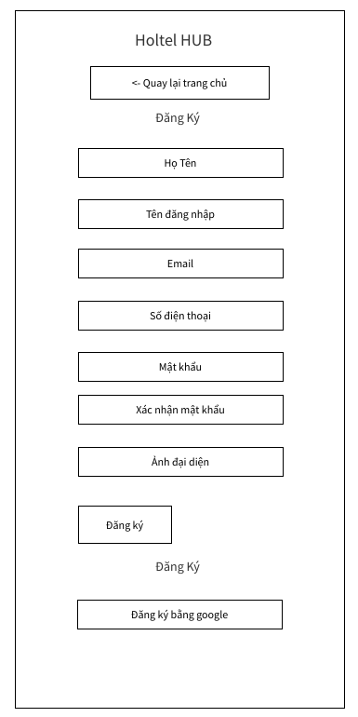

# | Field Name | Type | Mandatory | Max Length | Description
1 | Full Name | Text | Yes | 50 | User's full name
2 | Username | Text | Yes | 50 | Unique username for login
3 | Email | Email | Yes | 50 | User's email address
4 | Phone Number | Text | Yes | 50 | User's contact phone number
5 | Password | Password | Yes | 50 | Display "*" instead of actual characters
6 | Confirm Password | Password | Yes | 50 | Display "*" instead of actual characters
7 | Profile Picture | File | No | N/A | Optional profile image upload
8 | Register | Button | N/A | N/A | Submits the registration form
9 | Register with Google | Button | N/A | N/A | Allows registration using a Google account

2.1.3.2 Use Case Specification
UC ID and Name | UC02 - Sign Up (register)
Created By | Tran Dinh Huy | Date Created: | 22/07/2025
Primary Actor | User | Secondary Actors: | Admin
Trigger | User access in the website  User clicks on the "Register" button.
Description | This function allows users to register an account when they do not have an account to log into the HOTELHUB website or want to create a new account
Preconditions | The user must have internet access.  The user must have a valid email address or phone number.
Postconditions | User account created successfully.  The user is redirected to the Login page to proceed with the login process.
Normal Flow | The user access in website and click register button  The system display register page  The user enters the requested information (for example: name, email, password...). (see A1)  The user click register button  The system validates the entered information.  If the information is valid, the system creates a new account for the user.  The system checks user account information. (see E1, E2)  Users are redirected to the login page to perform the login process.
Alternative Flows | A1: User click return to home page  - The system display home page
Exception | E1: If the information entered is invalid (e.g. invalid email, phoneNumber, …)  - The system display an error message indicating the problem  - The user is asked to edit the information and resubmit.  E2: If the email or username is already used for another account  - The system displays an error message indicating that the email/username is already in use
Priority | High
Frequency of Use | Every time a new user wants to register to book or manage reservations.
Business Rule | - Users can register using a Google account (OAuth).  - Users can also register manually by entering required information (e.g., name, email, password).  - Email and username must not match the registered account in the system.
Other Information | - After registration, users can make bookings, view history.  - Email login streamlines access and reduces friction for new users.
AssumpionAssumpions | - Users have a valid email address.  - Users are familiar with form submission.

1.4 Forgot Password

1.4.1. Screen Design
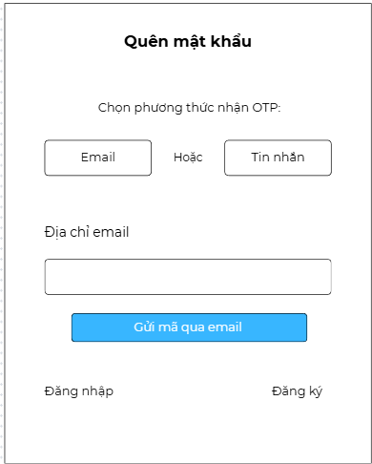

# | Field Name | Type | Mandatory | Max  Length | Description
1 | Your Email / Phone | Email / phone numbers | Yes | 50 | Choose Email or Phone numbers
2 | Sent | Button |  |  | Send password change address via  email

1.4.2 Use Case Specification
UCIDandName: | UC8: Forgot password (use PhoneNumber to reset password)
Created By: | Vo Hoang Phuc | Create at: | 18/06/2025
Primary Actor: | Customer | Secondary Actors: | None
Trigger: | The user selects the “Quên mật khẩu” option on the login screen
Description: | describes how a user can request an OTP to reset their password via Email or SMS.
Precondition:: | - The user has a registered account.  - The user has access to the registered email address or phone number.
Postconditions: | PRE–1: The user has previously registered in the system.  PRE–2: The user has access to their registered email address or phone number.
Normal Flow: | 1.0: Request OTP for Password Reset  - The user goes to the Forgot Password screen.  - The system displays a form asking the user to choose a method: Email or SMS.  - The user selects the method for receiving OTP.  - The user enters their registered email address or phone number.  - The system validates the entered information (see 1.0.E1, 1.0.E2, 1.0.E3).  - The system sends an OTP to the entered email/phone.  - The system displays a message confirming that the OTP has been sent.
Alternative Flows: | 1.1 Use different method if preferred  - The user initially selects Email but changes to SMS (or vice versa).  - The system updates the input form accordingly (email field ↔ phone number field).  - The user continues from step 4 of the Normal Flow.
Exceptions: | 1.0.E1 Mandatory field is blank  - The system notifies: "This field cannot be left blank."  - The user re-enters the value and continues from step 4.  1.0.E2 Invalid format  - The system notifies: "Invalid email/phone number format."  - The user re-enters the value and continues from step 4.  1.0.E3 Email or phone not found  - The system notifies: "No account is associated with this email/phone."  - The user re-enters the information and continues from step 4.  1.0.E4 System error (OTP not sent)  - The system displays: "An error occurred while sending OTP. Please try again."  - The user retries from step 6 or exits.
Priority: | High
Frequency of Use: | This feature is expected to be used occasionally, mostly when users forget their login credentials.
Business Rules: | BR1. Email must follow a valid format (e.g., user@example.com).  BR2. Phone numbers must follow a valid format (e.g., 0987654321).  BR3. OTP expires after 5 minutes.  BR4. Only one OTP request per minute is allowed per user.  BR5. A maximum of 5 OTP requests per day is allowed.
Other Information | This function is expected to be frequently used by users who forget passwords, especially after inactive periods.
Assumptions: | 1.Users have access to the internet and a valid email address or phone number.  2. The system has SMS and email service integrations properly configured.  3. OTPs are generated securely and stored temporarily for validation.  4. The user initiates the password reset process voluntarily without being forced by system failures.

UCIDandName: | UC8: Forgot password (use Email to reset password)
Created By: | Tran Dinh Huy | Create at: | 18/06/2025
Primary Actor: | Customer | Secondary Actors: | None
Trigger: | The user selects the “Quên mật khẩu” option on the login screen
Description: | describes how a user can request an OTP to reset their password via Email.
Precondition:: | - The user has a registered account.  - The user has access to the registered email address.
Postconditions: | PRE–1: The user has previously registered in the system.  PRE–2: The user has access to their registered email address.
Normal Flow: | 1.0: Request OTP for Password Reset  - The user goes to the Forgot Password screen.  - The system displays a form asking the user to choose a method: Email or SMS.  - The user selects the method for Email OTP.  - The user enters their registered email address.  - The system validates the entered information (see 1.0.E1, 1.0.E2, 1.0.E3).  - The system sends an OTP to the entered email.  - The system displays a message confirming that the OTP has been sent
Alternative Flows: | - If the user enters the wrong OTP, there will be an error message and the user must re-enter it.
Exceptions: | 1.0.E1 Mandatory field is blank  - The system notifies: "This field cannot be left blank."  - The user re-enters the value and continues from step 4.  1.0.E2 Invalid format  - The system notifies: "Invalid email format."  - The user re-enters the value and continues from step 4.  1.0.E3 Email not found  - The system notifies: "No account is associated with this email."  - The user re-enters the information and continues from step 4.  1.0.E4 System error (OTP not sent)  - The system displays: "An error occurred while sending OTP. Please try again."  - The user retries from step 6 or exits.
Priority: | High
Frequency of Use: | This feature is expected to be used occasionally, mostly when users forget their login credentials.
Business Rules: | BR1. Email must follow a valid format (e.g., user@example.com).  BR2. OTP expires after 5 minutes.  BR3. Only one OTP request per five minute is allowed per user.
Other Information | This function is expected to be frequently used by users who forget passwords, especially after inactive periods.
Assumptions: | 1.Users have access to the internet and a valid email address or phone number.  2. The system has SMS and email service integrations properly configured.  3. OTPs are generated securely and stored temporarily for validation.  4. The user initiates the password reset process voluntarily without being forced by system failures.

1.5 User Profile

1.5.1 screen design
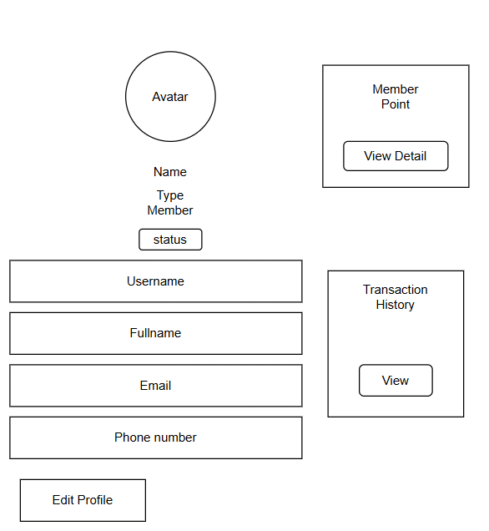

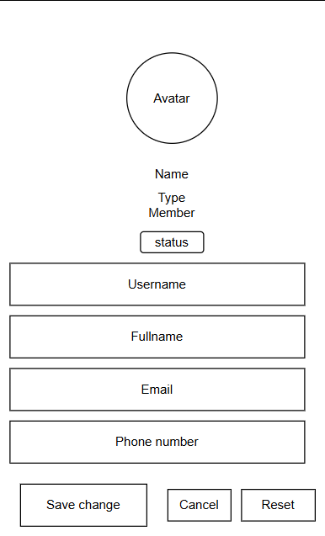

# | Field Name | Type | Mandatory | Max  Length | Description
1 | User name | text | Yes | 50 | User name
1 | Full Name | text | Yes | 50 | User's full name.
2 | Email | email | Yes | 50 | User's email address.
3 | Phone | text | Yes | 50 | User's phone number.
10 | Edit profile | button | Yes | N/A | Button to edit profile to the user profile  information.

1.5..2 Use Case Specification
UC ID and Name: | UC06 - User profile (update)
Created By: | Pham Nguyen | Date Created: | 18/06/2025
Primary Actor: | Customer | Secondary Actors: | None
Trigger: | TRG-01:The user selects the profile icon  TRG-02: User clicks the "Save changes" button after updating profile information.
Description: | This function allows users to view and update their personal profile information in the system.

Precondition:: | PRE-01: User has logged into the system.  PRE-02: User has access to personal profile page
Postconditions: | The user's profile information was successfully updated.  The user receives a notification confirming the successful update.
Normal Flow: | The user logs into the system.  The user visits the personal profile page.  Users update personal information (e.g. name, email, phone number). The user clicks the "Save Changes" button (TRG-01).  The system authenticates and updates information in the database. The system displays a message confirming the successful update.
Alternative Flows: | If the update information is invalid (go to Exception Flow ).
Exceptions: | ● If the update information is not valid:  ● The system displays an error message indicating invalid information.  ● The user is asked to edit the information and resubmit.
Priority: | High
Frequency of Use: | Every time a user wants to view or update their personal profile information.
Business Rules: | Personal information must be kept confidential and can only be accessed by the account owner.

Other Information | User should be advised to periodically update their profile information to ensure accuracy.
Assumptions: | The user is logged in to the system and has access to the personal profile page.

1.6 Contact Us

1.6.1 Screen Design
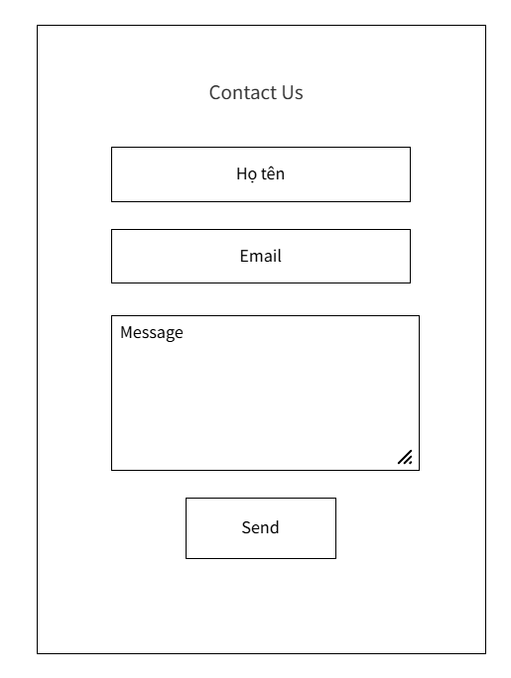

# | Field Name | Type | Mandatory | Max  Length | Description
1 | Fullname | text | Yes | N/A | The full name of the customer.
2 | Email | email | Yes | N/A | The email of a customer.
3 | Message | text | Yes | N/A | The message of customer want to send.
4 | Send | button | Yes | N/A | Button to send for  Submit a message to contact.

1.6.2 Use Case Specification
UC ID and Name: | UC07 - Contact
Created By: | Trần Đình Huy | Date Created: | 18/07/2025
Primary Actor: | Customer | Secondary Actors: | None
Trigger: | The user access the contact us page  The user clicks the Send button after filling in the contact form.
Description: | This use case allows user to send a message to the hotel for inquiries, feedback, or support through the Contact form.
Preconditions: | - The user has accessed the Contact page.  - All required fields are filled.
Postconditions | - The message is submitted and either a success or failure message is shown.

Normal Flow:
  1. The user navigates to the Contact page.
  2. Users fill in their Fullname, Email, and Message.
  3. The user clicks the Send button.
  4. The system validates the input.
  5. The system sends the message to the server.
  6. The system displays a confirmation message.
Alternative Flows: | - A1: One or more required fields are empty → System shows validation error.  - A2: Email format is invalid → System shows email format error.
Exceptions: | - System error while sending a message → display “An error occurred, please try again later.”  - Email is not in correct format will return to step 2
Priority: | High
Frequency of Use: | Frequently – Expected to be used whenever customers need to contact the hotel.
Business Rules: | - Fullname, Email, and Message are required.  - Email must be in the correct format.  - Duplicate messages are allowed (no restriction).
Other Information: | - The form should work on both desktop and mobile.  - A loading indicator and success/error message should appear after submission.

Assumptions: | - The user has a valid email address.  - The system can connect to the server to send the message.

1.7 Booking Room Online

1.7.1.1 Screen Design

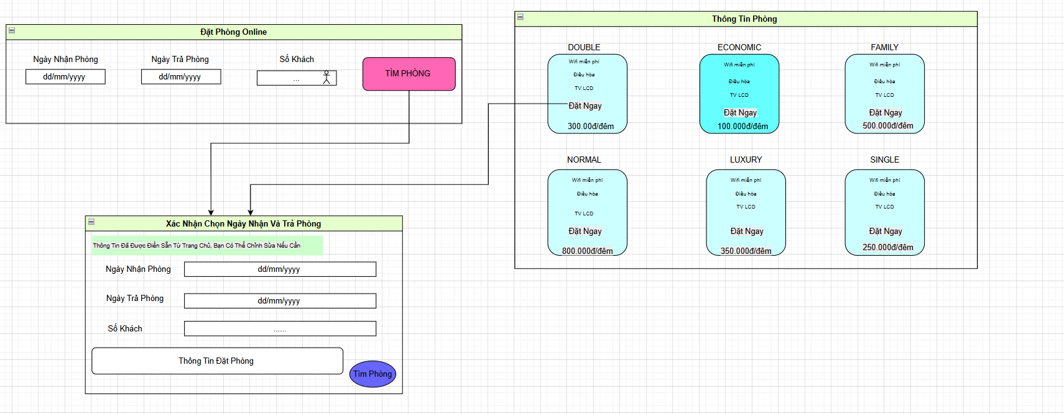

# | Field Name | Type | Mandatory | Max  Length | Description
1 | Check-in Date | Date | Yes | N/A | The date the customer wants to check in.
2 | Check-out Date | Date | Yes | N/A | The date the customer wants to check out.
3 | Number of Guests | Number | Yes | 100 | Displays the number of guests.
4 | Find Room | Button | Yes | N/A | Find available rooms based on check-in/check-out dates and number of guests.
5 | Entered Information | Label | Yes | N/A | Reminder: “Information has been pre-filled from the homepage. You can edit it if needed.”
6 | Check-in Date (confirmation) | Date | Yes | N/A | Allows editing if needed..
7 | Check-out Date (confirmation) | Date | Yes | N/A | Allows editing if needed..
8 | Number of Guests (confirmation) | Number | Yes | 100 | Allows editing if needed..
9 | Booking Information | number | Yes | N/A | Confirm to display booking information.
10 | Find Room | Button | Yes | N/A | Find Room button after room editing

1.7.1.2 : Use Case Specification

UC ID and Name: | UC08- Booking Room Online
Created By: | Dương Trọng Lực | Date Created: | 13/06/2025
Primary Actor: | Customer | Secondary Actors:
Trigger: | TRG 01 - The user enters the check-in date, check-out date, and number of guests, then clicks “Find Room.”.
Description: | Allows the user to search for and select a room type based on the desired dates and number of guests.
Preconditions: | PRE-1: The user accesses the booking interface  PRE-2 : An internet connection is available
Postconditions | POST-1 : The system displays a list of corresponding rooms for the user to select and book.

Normal Flow: | 1. User enters check-in date, check-out date, and number of guests.  2. Clicks “Find Room”.  3. System displays a confirmation screen.  4. User verifies and clicks “Find Room” again.  5. System shows available rooms based on input.
Alternative Flows: | - AF1: If the date is missing or in the wrong format → the system displays an error.  - AF2: If more than 100 guests are entered → display the message “Value must be less than or equal to 100.”
Exceptions: | - E1 Lost internet connection  - E2 The system fails to respond due to error handling
Priority: | High
Frequency of Use: | Whenever the user wants to search for and book a room online.
Business Rules: | - BR1 Check-in date must not be earlier than the current date  - BR2 Check-out date must be later than the check-in date  -BR3 Number of guests must not exceed 100 people
Other Information: | -Room types have different prices and amenities, which are displayed in the next step.

Assumptions: | -The displayed information matches the room database  -There is an intermediate booking processing system

1.7.2.1 Screen Design
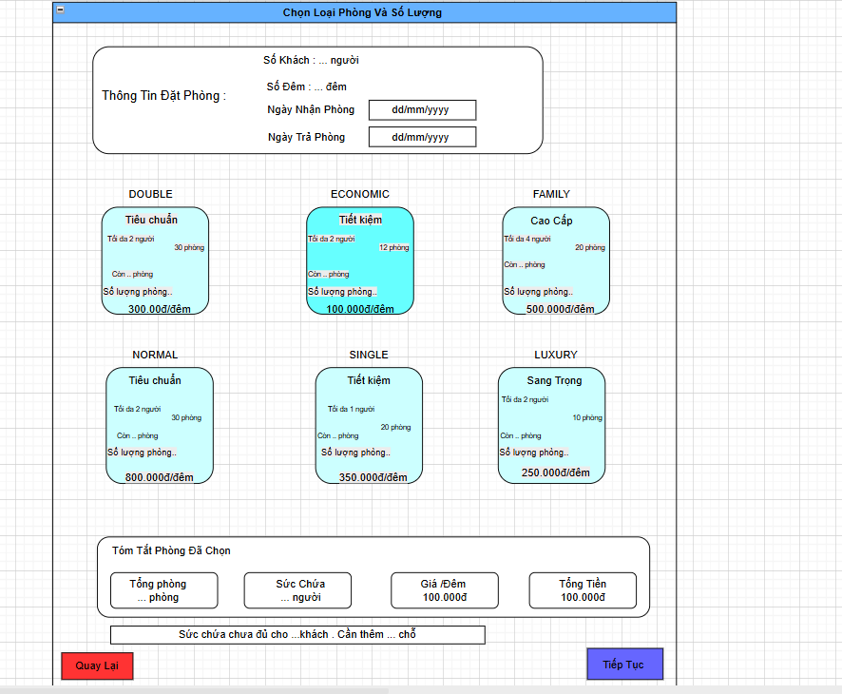

# | Field Name | Type | Mandatory | Max  Length | Description
1 | Number of Guests | number | Yes | 100 | Total number of guests staying.
2 | Number of Nights | number | Yes | N/A | Number of nights the guest will stay.
3 | Check-in Date | label | Yes | N/A | The date the guest checks in.Must not be before the current date
4 | Check-out Date | label | Yes | N/A | The date the guest checks out.
5 | Room Type | label | Yes | 6 | Displayed name of the room type.
6 | Room Description | label | Yes | N/A | Base on room type (example :”Economy”, “Luxury”)
7 | Capacity per Room | label | Yes | 4
  How many people per room.
8 |  | label | Yes | 122 | Number of rooms still available.
  Available Rooms
9 | Rooms to Book | label | Yes | =< available rooms>=0 | Number of rooms user wants to book.
10 |  | label | Yes | 2.000.000đ | Displayed based on room type.
  Price per Night
11 |  | label | Yes | N/A | Total number of rooms selected across all types.
  Total Rooms Selected
12 | Total Capacity | label | Yes | N/A | Total capacity based on selected room types and quantities.
13 | Average Price per Night | label | Yes | N/A
  Calculated average price per night.
14 |  | label | Yes | N/A | Number of nights * total room cost.
  Total Cost

1.7.2.2 Use Case Specification

UC ID and Name: | UC08.1- Select Room Type and Quantity
Created By: | Dương Trọng Lực | Date Created: | 14/06/2025
Primary Actor: | Customer | Secondary Actors:
Trigger:
  TRG 01- The user wants to select a room type, number of rooms, and number of guests to make a reservation.
Description: | The user enters check-in/check-out dates, number of guests, number of nights, and selects room type and quantity. The system will calculate the total cost and check if the total capacity is sufficient before allowing the user to proceed
Preconditions: | PRE–1: The user has accessed the room selection interface.
Postconditions
  POST–1: Selected room information, stay dates, number of guests, and total amount are saved for the payment step.
  POST–2: Proceed to the next step if the input is valid.

Normal Flow:
  Room Booking
  1. The user enters the number of guests, number of nights, check-in and check-out dates.
  2. The system validates the dates (must not be in the past, and check-out ≥ check-in).
  3. The user selects the number of rooms for each available room type.
  4. The system updates: total rooms, total capacity, price per night, and total amount.
  5. If the capacity is insufficient → a message is shown indicating how many more spots are needed.
  6. The user clicks "Continue" to move to the next step.
Alternative Flows: | AL1.1 Invalid date input  → The system shows an error and does not allow to proceed.  AL1.2 No room selected  → The system requires the user to select at least one room type.
Exceptions:
  E1: Check-in date is in the past → display error.
  E2: Check-out date is earlier than check-in date → display error.
  E3: Capacity is insufficient → show message indicating how many more spots are needed.
Priority: | High
Frequency of Use: | Very frequent – this is a key step in the booking process.
Business Rules: | BR1: Each room type has a different price and quantity:  - DOUBLE: 300,000 VND/night, 30 rooms  - ECONOMIC: 100,000 VND/night, 12 rooms  - FAMILY: 500,000 VND/night, 20 rooms  - NORMAL: 800,000 VND/night, 30 rooms  - SINGLE: 350,000 VND/night, 20 rooms  - LUXURY: 250,000 VND/night, 10 rooms  BR2: The system must correctly calculate total cost = number of rooms × number of nights × price per room type.  BR3: Display a warning if the total capacity is not enough for the number of guests.
Other Information: | The user interface includes dropdowns for each room type, showing capacity, price per night, and real-time updated total cost.

Assumptions:
  - Room type data and availability are updated in real time from the system.
  - The system has built-in logic for date and capacity validation.

1.7.3.1 Screen Design
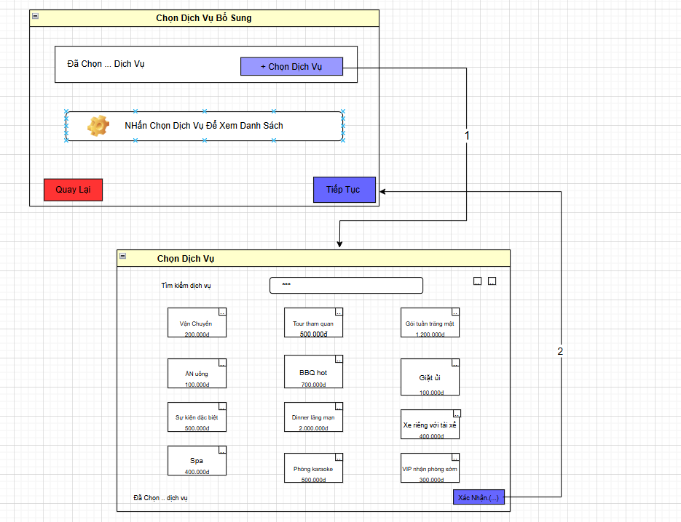

# | Field Name | Type | Mandatory | Max  Length | Description
1 | Selected ... services | label | No | 255
  Displays the list of selected services, aggregated from ServiceName
2 | + Select Service | button | No | N/A | Opens the “Select Service” screen to add more services
3 | Service selection guide | label | No | N/A
  Instruction text: “Click Select Service to View the List”
4 | Back | Button | No | N/A | Navigates back to the previous screen.
5 |  | Button | Yes | N/A | Proceeds when at least one service is selected
  Continue
6 | Service search | textbox | No | 50 | Enter keywords to search by ServiceName in the database
7 | Service checkbox | checkbox | No | N/A | Select one or more services from the list
8 | Service Name | Label | Yes | N/A | Displays the service name from the ServiceName column in the Service table
9 | Service Price | Label | Yes | N/A | Displays the service price from the Price field (float type).
10 | Confirm (...) | Button | Yes | N/A | Confirms selected services and returns to “Additional Services” screen
11 | Selected ... services | Label | No | 255 | Displays total number of selected services.

1.7.3.2 Use Case Specification

UC ID and Name: | UC08.2 -Select Additional Services
Created By: | Dương Trọng Lực | Date Created: | 16/06/2025
Primary Actor: | Customer | Secondary Actors:
Trigger: | TRG 01 - After selecting rooms, the user is prompted to choose additional services to enhance the experience.
Description: | The user can choose additional services such as transportation, meals, tours, spa, etc. The system calculates the total service cost and stores it for the final invoice.
Preconditions:
  PRE–1: The user has completed the room selection step.
  PRE–2: The system displays a list of currently available services.

Postconditions:
  POST–1: The selected services list is saved and shown during the payment step.
  POST–2: The system adds the total service cost to the final invoice.
Normal Flow: | Select Services  1. The user clicks “+ Select Services.”  2. The system opens the list of available services.  3. The user ticks one or more services.  4. The user clicks “Confirm.”  5. The system returns to the previous screen and shows the number of selected services.  6. The user clicks “Continue” to proceed to the next step.
Alternative Flows: | AF 1: No service selected → The system allows proceeding without adding services.  AF 2 : No search results → Display “No matching services found.”
Exceptions Flow: | E1: Connection lost while selecting services → Show connection error message.  E2: A service is temporarily unavailable → Notify that the service is not available.
Priority: | Medium
Frequency of Use: | Optional but fairly common among high-demand users.
Business Rules: | BR1: Each service has a fixed price (e.g., Transportation – 200,000 VND, Spa – 400,000 VND, Tour – 500,000 VND, Laundry – 100,000 VND, etc.).  BR2: The system adds up the total service cost upon confirmation.  BR3: Users are allowed to unselect or remove selected services.

Other Information: | -The interface allows users to search for services, select them with checkboxes, and view the selected list.  -Suggested services are displayed along with prices below each item.
Assumptions:
  - The list of services is managed in the backend and can change dynamically.
  - The user may skip this step if not needed.

1.7.4.1 Screen Design
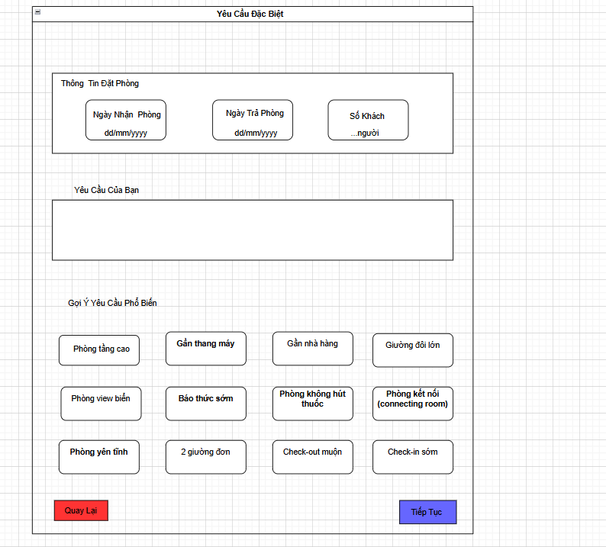

# | Field Name | Type | Mandatory | Max Length | Description
1 | Date check in | Date | Yes | N/A | Date customer checkin
2 | Date check out | Date | Yes | N/A | Date customer checkout
3 | Number of customer | Number | Yes | N/A | Number of person booking for room
4 | Request-Note | Text | No | 255 | Note if customer have require
5 | Recommend require | Button | No | N/A | Suggest frequently used customer requests

1.7.4.2 Use Case

UC ID and Name: | UC08.3 - Special Request Information
Created By: | Dương Trọng Lực | Date Created: | 17/6/2025
Primary Actor: | Customer | Secondary Actor: | None
Trigger: | TRG-01: The user reaches the "Special Request" step in the room booking process and wants to enter or select special accommodation requests.

Description | This use case describes how the user inputs or selects special requests such as early check-in, non-smoking room, ocean view, etc., as part of their room booking preferences.
Preconditions: | PRE-1: The user has entered basic booking information (check-in date, check-out date, number of guests).  PRE-2: The system has loaded the list of suggested requests.
Postconditions: | POST-1: The user’s special requests are saved to the booking record.  POST-2: The system proceeds to the next step in the booking process.
Normal Flow: | Enter Special Requests  - The user sees the "Special Request" page.  - The system displays:  -Room information fields:  +Date Checkin  +Date CheckOut  +Number of Guest  -Input box for entering custom request  -A list of suggested requests  - The user selects one or multiple suggestions.  - The user optionally types their own request in the text input.  - The user clicks Continue to proceed.  - The system saves the selected/entered requests to the booking record.
Alternative Flows: | AF1 : No special request selected or entered  -The system allows proceeding without any input.
Exceptions: | EX1: System cannot load the list of popular suggestions → Displays: “Không thể tải danh sách gợi ý.”  EX2: Booking data (dates or guests) is missing → Redirects to the previous step.
Priority: | Medium
Frequency of Use: | High during room booking, especially for customers with specific needs.
Business Rules: | BR1: Selected suggestions are automatically added to the special request list.
Other Information: | Expected to improve customer satisfaction by handling preferences effectively.
Assumptions: | -The user understands the nature of suggested requests.  -The hotel has the capacity to fulfill some or all of the requests depending on availability.

1.7.5.1 Screen Design
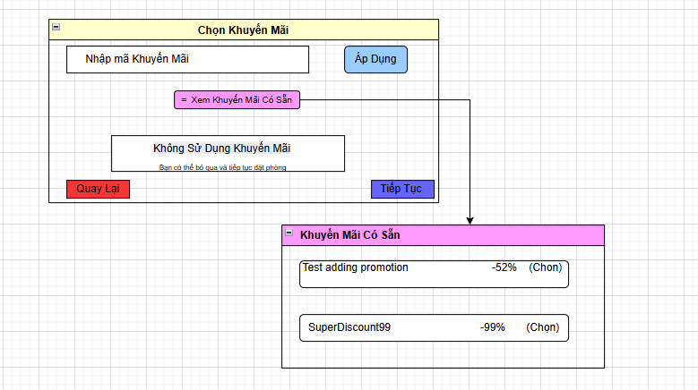

# | Field Name | Type | Mandatory | Max Length | Description
1 | Promotion code | Text | No | N/A | discount code
2 | Apply | Button | Yes | N/A | Apply discount code at checkout
3 | View available promo codes | Text | No | N/A | Discount codes available
4 | Discount number | Button | Yes | 100 | User choose Discount
5 | Continue | Button | Yes | N/A | Continue button after room apply promotion

1.7.5.2 Use Case

UC ID and Name: | UC08.4 - Apply Promotion Code
Created By: | Dương Trọng Lực | Date Created: | 18/6/2025
Primary Actor: | Customer | Secondary Actor: | None
Trigger: | TRG-01: The user wants to apply a promotion code during the room booking process.

Description | This use case describes the flow where the user either enters a promotion code manually or selects one from a list to receive the corresponding discount during booking.
Preconditions: | PRE-1: The user is logged in and currently in the booking flow.  PRE-2: The list of available promotions is preloaded from the system.
Postconditions: | POST-1: The promotion code is successfully applied (if valid).  POST-2: The total amount is updated based on the promotion discount.
Normal Flow: | Apply Promotion Code  1.The user navigates to the "Apply Promotion" section of the booking page.  2.The user can either:  – Enter a promotion code manually, or  – Click “View Available Promotions” to choose from a list:  +Test adding promotion (-52%)  +SuperDiscount99 (-99%)  3.The user selects a promotion and clicks "Apply".  4.The system validates the promotion code.  5.If valid, the system applies the discount and updates the total booking amount.  6.The system displays the updated price and the applied promotion.  7.The user clicks "Confirm" to finalize the promotion application.
Alternative Flows: | AF1: Empty promotion code input  -The system displays: “Please enter a promotion code or select from the available list.”  AF2: Invalid or expired promotion code  -The system displays: “Invalid or expired promotion code.”  AF3: Promotion code not applicable to booking  -The system displays: “This promotion code does not apply to the current booking.”  AF4: Connection error while applying promotion code  -The system displays: “Unable to connect to validate the promotion code. Please try again later.”
Exceptions: | E1: Promotion code system unavailable  E2: Promotion database not loaded  E3: UI rendering failure for promotions
Priority: | High
Frequency of Use: | Whenever frequently used during the room booking process, especially during holidays or promotional events.
Business Rules: | BR1: Each promotion code is valid only for specific booking conditions.  BR2: Only one promotion code can be applied at a time.  BR3: Promotion code format: [letters + numbers], case-insensitive (e.g., SuperDiscount99).  BR4: If multiple valid codes are selected, the one with the highest discount is prioritized.  BR5: All error messages appear below the respective input fields in red.
Other Information: | This use case is expected to be triggered often during promotional campaigns and peak travel seasons.
Assumptions: | -The promotion validation API is always available.  -Promotion data is always up to date.  -The user understands the concept of promotion codes and how to use them.

1.7.6.1 Screen Design

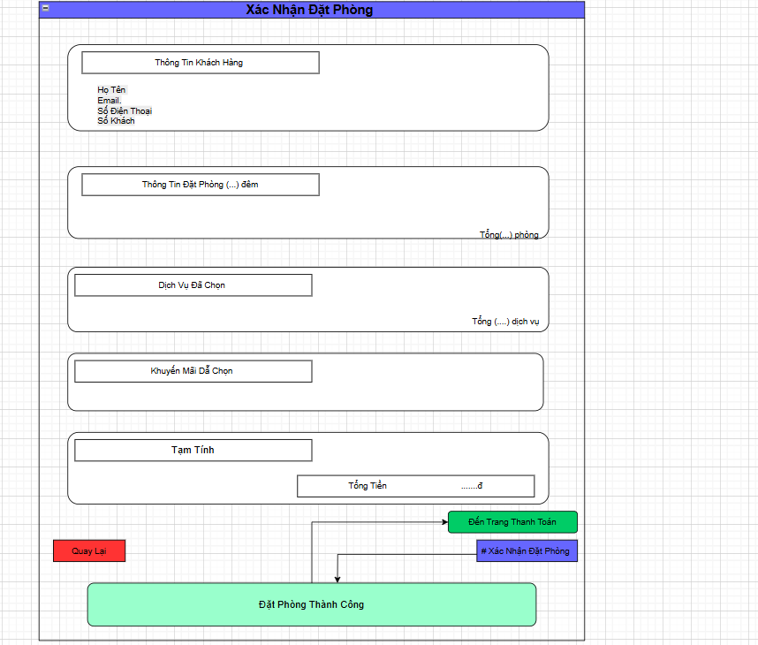

# | Field Name | Type | Mandatory | Max  Length | Description
1 | Full Name | text | Yes | 150 | Displays the customer's full name (from “Fullname” column).
2 | Email | Email | Yes | 150 | Displays the customer's email address (from Email column)
3 | Phone Number | text | Yes | 50 | Displays the customer's phone number (from PhoneNumber column)
4 |  | label | Yes | 100
  Number of Guests
  Displays the number of guests entered previously
5 |  | label | Yes | 255 | Displays booking details and the number of nights.
  Booking Info (...nights)
6 |  | label | Yes | N/A | Displays the total number of rooms booked.
  Total (... rooms)
7 |  | Label | No | N/A | Displays the list of selected services
  Selected Services
8 |  | Label | Yes | 50 | Displays the total number of selected services
  Total (... services)
9 |  | Label | No | 255 | Displays the list of applied promotion codes (if any)
  Selected Promotions
10 | Total Amount | Label | Yes | N/A | Displays the estimated total cost (rooms + services - promotions)
11 | Back | Button | No | N/A | Returns to the previous screen
12 | Confirm Booking | Button | Yes | N/A | Confirms and submits the booking information
13 | Proceed to Payment | Button | Yes | N/A | Redirects to the payment screen
14 |  | Button | Yes | N/A | Displays a message after booking is completed successfully
  Booking Successful
  Message

1.7.6.2 Use case
UC ID and Name: | UC08.5 Confirm Booking
Created By: | Dương Trọng Lực | Date Created: | 20/06/2025
Primary Actor: | Customer | Secondary Actors:
Trigger: | TRG 01 - After selecting rooms, services, and promotions, the user confirms all information before proceeding to payment.
Description:
  The screen summarizes all booking information: customer details, room information, selected services, promotions, and estimated total cost. The user reviews and proceeds to the payment step.
Preconditions: | PRE–1: The user has completed the steps for selecting rooms, services, and promotions.  PRE–2: The system has calculated the total cost and displays accurate information.

Postconditions: | POST–1: The system navigates to the payment page.  POST–2: The booking status is recorded as “pending payment.”
Normal Flow: | Confirm Booking Information  1. The system displays:  – Customer details (full name, email, phone number, number of guests)  – Booked room information  – List of selected additional services  – Promotions (if any)  – Estimated total cost  2. The user reviews all the displayed information.  3. The user clicks “Go to Payment Page.”
Alternative Flows: | AF 1: No customer information (full name, email) → display a prompt to enter required details.  AF 2: Clicking “Confirm” with missing information → show a confirmation error.
Exceptions Flow:
  E1: Incomplete information display → System shows an error and asks to retry.
  E2: Unable to connect to payment → Display network error warning.
Priority: | High
Frequency of Use: | Every time a booking is made
Business Rules:
  BR1: All information must be valid before proceeding to payment.
  BR2: The displayed price must be the final price (including services and promotions).
  BR3: Confirmation is not allowed if any required information is missing.

Other Information: | Two options available:  – Go back  – Proceed to payment page (ends current use case and transitions)
Assumptions:
  – Information from previous steps is stored in session/local state.
  – The system will block progression if data errors are present.
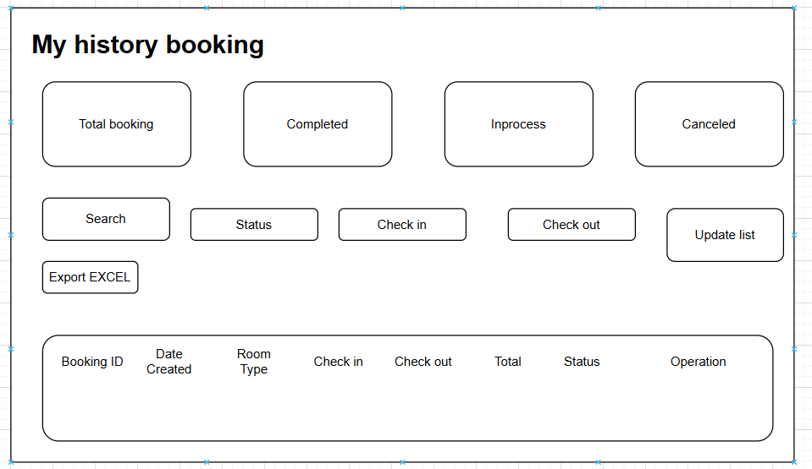

# | Field Name | Type | Mandatory | Max  Length | Description
1 | Total booking | Number | Yes | 150 | Displays the number of booking room
2 | Completed | Number | Yes | 150 | Displays the number completed booking
3 | Search | Text | Yes | 150 | Search by ID type..
4 | status | text | yes | 150 | All status booking
 | Export EXCEL | button | no | N/A | Export excel form
5 | Update list | button | no | N/A | Update list by filter
5 | Check in | date | yes | N/A | Choose check in date
6 | Check out | date | yes | N/A | Choose check out date
7 | In process | number | Yes | 50 | Displays status process user history booking
8 |  | number | Yes | 100
  Canceled
  Display number of booking canceled

UC ID and Name: | UC Manage Booking History
Created By: | Dương Trọng Lực | Date Created: | 20/06/2025
Primary Actor: | Customer | Secondary Actors:
Trigger: | TRG 01 - The user accesses the booking history page to view or manage their created bookings.
Description:
  The page displays a summary of all booking history created by the user, including total bookings, completed bookings, pending bookings, canceled/completed bookings. Users can filter by date range, export to Excel, or update booking status.
Preconditions: | PRE–1: The user is logged into the system. PRE–2: The system has retrieved and displayed the user's booking history.

Postconditions: | POST–1: The user views or updates the booking history. POST–2: Exported Excel file is generated if requested.  ”
Normal Flow: | The system displays:  Total bookings  Completed bookings  Pending bookings  Canceled/Completed bookings  Filter options (date range)  Export to Excel button  - The user reviews the displayed information.  - The user applies filters or clicks "Export Excel" if needed.
Alternative Flows: | AF 1: No bookings found → display a message "No bookings created yet."  AF 2: Invalid date range → show an error prompting to enter a valid range.
Exceptions Flow:
  E1: Data loading failure → System shows an error and asks to retry.
  E2: Export to Excel fails → Display export error warning.
Priority: | High
Frequency of Use: | Frequently, as users manage their bookings regularly
Business Rules:
  BR1: All booking data must be accurate and up-to-date.
  BR2: Users can only view or manage their own bookings.
  BR3: Export functionality requires a valid date range.

Other Information: | Two options available:  - Apply filters to view specific bookings  - Export to Excel (ends current action and generates file)
Assumptions:
  - Booking data is stored and accessible in the system.
  - The system validates user access before displaying data.

1.8 Payment

1.8.1 Screen Design
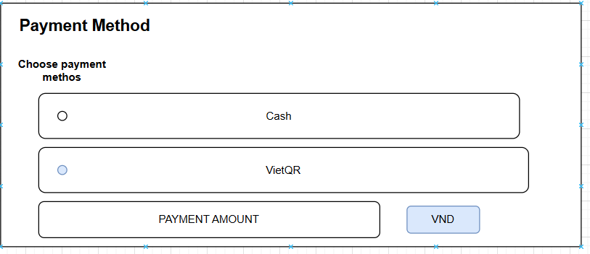

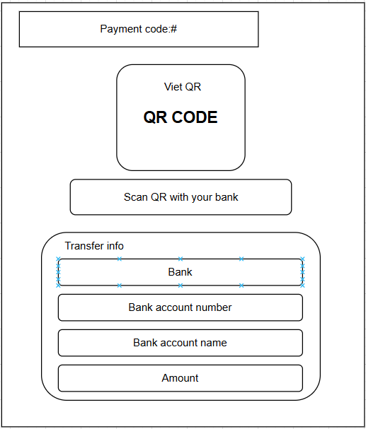

# | Field Name | Type | Mandatory | Max  Length | Description
1 | Payment Method | dropdown | Yes | N/A | Dropdown to select the payment method (e.g.,Cash ATM, VietQr).
2 | Bank name | text | Yes | 50 | VietQR payment bank name
3 | Account number | text | Yes | 50 | Account holder's bank account number
4 | Amount | text | Yes | 50 | Amount payable
5 | Transfer Detail | text | Yes | 50 | Send the transfer content with the code
6 | Confirm | button | Yes | N/A | Submits the payment completed

1.8.2 Use Case Specification
UC ID and Name: | UC09 -Payment
Created By: | Pham Nguyen | Date Created: | 14/06/2025
Primary Actor: | Customer | Secondary Actors: | Receptionist
Trigger: | The user selects a payment method, enters VietQR, and clicks Confirm.
Description: | This use case allows users to complete the booking by paying with bank transfer
Preconditions: | - Booking must already exist.  - The payment screen is displayed with the selected room and amount.  - The payer needs to have sufficient account balance to make the payment.  - A Bank Account:You must have an account with a bank in Vietnam.  - Mobile Banking App: You need to have the mobile banking application  - Internet Connection: A stable internet connection is required on your smartphone to access your banking app and process the transaction.  - Confirm the transaction details and authorize the payment, usually with a PIN, fingerprint, or facial recognition.

Postconditions: | - Payment is processed.  - Your bank account is debited by the exact transaction amount.  - Booking status is updated to "Paid".  - You receive a success confirmation (e.g., in-app notification, SMS)  - The transaction is recorded in your bank statement.
Normal Flow: | 1. after finish reviewing invoice, customer navigated to payment page  2. The user enters payment with VietQR.  3. Customer clicks Confirm.  4. QR code generation and display system.  5. Customer on banking app.  6. Processing and response from the bank.  7. Sales system confirms and completes.
Alternative Flows: | AF 1:  1. The receptionist selects the payment method from the dropdown.  2. The receptionist enters payment with Cash.  3. The receptionist clicks Confirm.  4. The receptionist receives money from customer  5. Confirm.  AF2:  1. after finish reviewing invoice, receptionist navigated to payment page  2. The receptionist enters payment with VietQR.  3. Receptionist clicks Confirm.  4. QR code generation and display system.  5. Customer on banking app.  6. Processing and response from the bank.  7. Sales system confirms and completes.
Exceptions Flow: | - user decides not to pay-click the button “Close”.  - Wrong transfer information (Content or Amount).  - QR code or session expired.  - user clicks "Confirm transfer" but has not transferred money.  - The recipient's bank or payment gateway is down.
Priority: | High
Frequency of Use: | Frequently – For every booking paid by Banking
Business Rules: | BR1: The transfer content code must be unique.  BR2: QR codes must contain accurate information: QR codes when generated must encode accurately  BR3: Transactions must match 100% accurately:(amount, transfer content).  BR4: Partial payments are not accepted.  BR5: booking online only receive money through online payment system(VietQR)

Other Information: | - User has valid Bank account  - Payment gateway is active and properly configured.  - Should include validation messages.
Assumptions: | - User has a valid Bank account.  - Payment gateway is active and properly configured.

1.9 Service
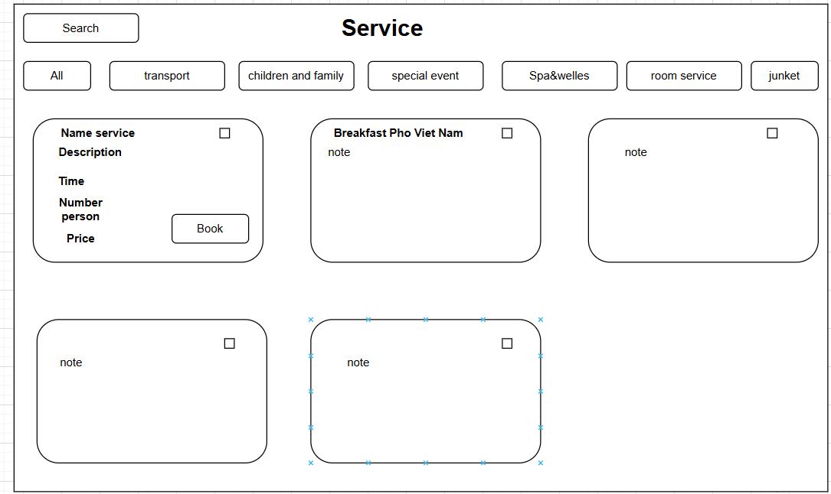

# | Field Name | Type | Mandatory | Max  Length | Description
1 | Name service | text | N/A | 225 | Display the service name
2 | Description | text | N/A | 255 | Display the description of service
2 | Time | text | N/A | N/A | Time use service
3 | Number person | number | N/A | 100 | Max number person use service
4 | Price | number | N/A | 100 | Price of service
2 | Book | button | No | N/A | Customers have the  option of choosing  services.

1.10 Feedback

1.10.1 Screen Design
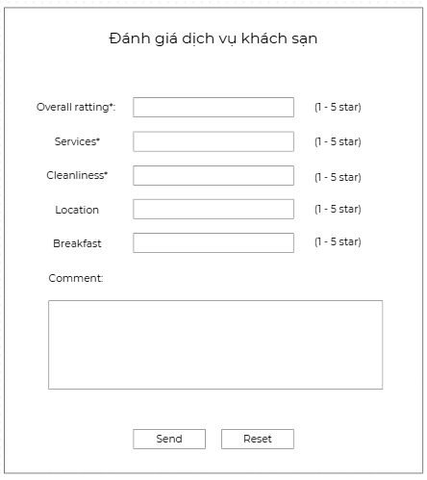

# | Field Name | Type | Mandatory | Max Length | Description
1 | bookingID | number | Yes | N/A | Booking ID used to link the review with the reservation
2 | overallRating | integer | Yes | 1 | Overall rating (1–5 stars)
3 | serviceRating | integer | Yes | 1 | Service quality rating (1–5 stars)
4 | cleanlinessRating | integer | Yes | 1 | Cleanliness rating (1–5 stars)
5 | locationRating | integer | No | 1 | Hotel location rating (1–5 stars)
6 | breakfastRating | integer | No | 1 | Breakfast rating (1–5 stars)
7 | comment | textarea | No | N/A | Additional customer comment (optional)
8 | sendButton | button | Yes | N/A | Submit button for sending the review
9 | resetButton | button | No | N/A | Button to reset all fields in the form

1.10.2 Use Case

Use Case ID |  | UC-046 |  |  | Feedback of customer
Author |  | Vo Hoang Phuc |  |  | Date | 20/07/2025
Actor |  | Customer
Priority |  | Medium
Description |  | This use case describes the process by which a hotel guest submits service feedback by filling in and sending the feedback form.
Precondition |  | PRE – 1: The user has already used the hotel service
Trigger |  | The user wants to submit feedback about the hotel service after using it.
Post-Condition |  | POST – 1: The feedback is stored in the system.  POST – 2: The user receives a confirmation message indicating successful submission.
Normal Flow: |  | 1.0: Submit Hotel Feedback  - The user navigates to the feedback page.  - The system displays the feedback form with fields: Overall rating*, Services*, Cleanliness*, Location, Breakfast, and Comment.  - The user fills in all required fields and clicks the “Send” button.  - The system validates the input data  - If the data is valid, the system saves the feedback and displays a success message.
Alternative Flows: |  | 1.1: User clicks “Reset”  - The user clicks the “Reset” button.  - The system clears all input fields and resets the form to its default state.
Exceptions: |  | Mandatory fields are left blank
Business Rules: |  | BR1: Fields Overall rating, Services, Cleanliness are mandatory.  BR2: Rating values must be between 1 and 5 stars.  BR3: Comment must not exceed 500 characters.
Other Information: |  | - The feedback form may only be accessible after the user has completed a booking.  - Collected feedback will be used to evaluate and improve service quality.

2.manager

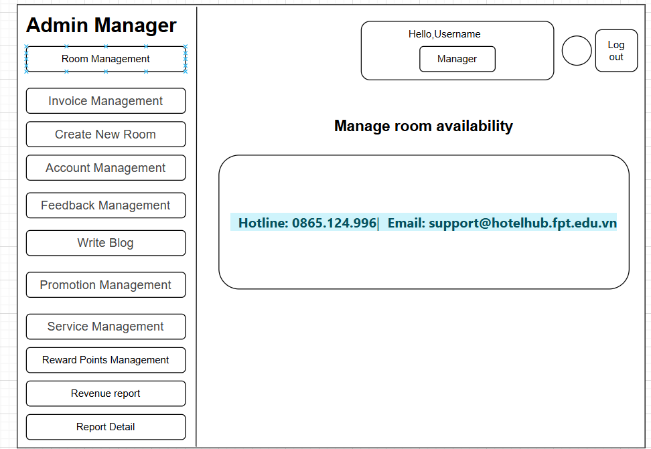
1. home page admin 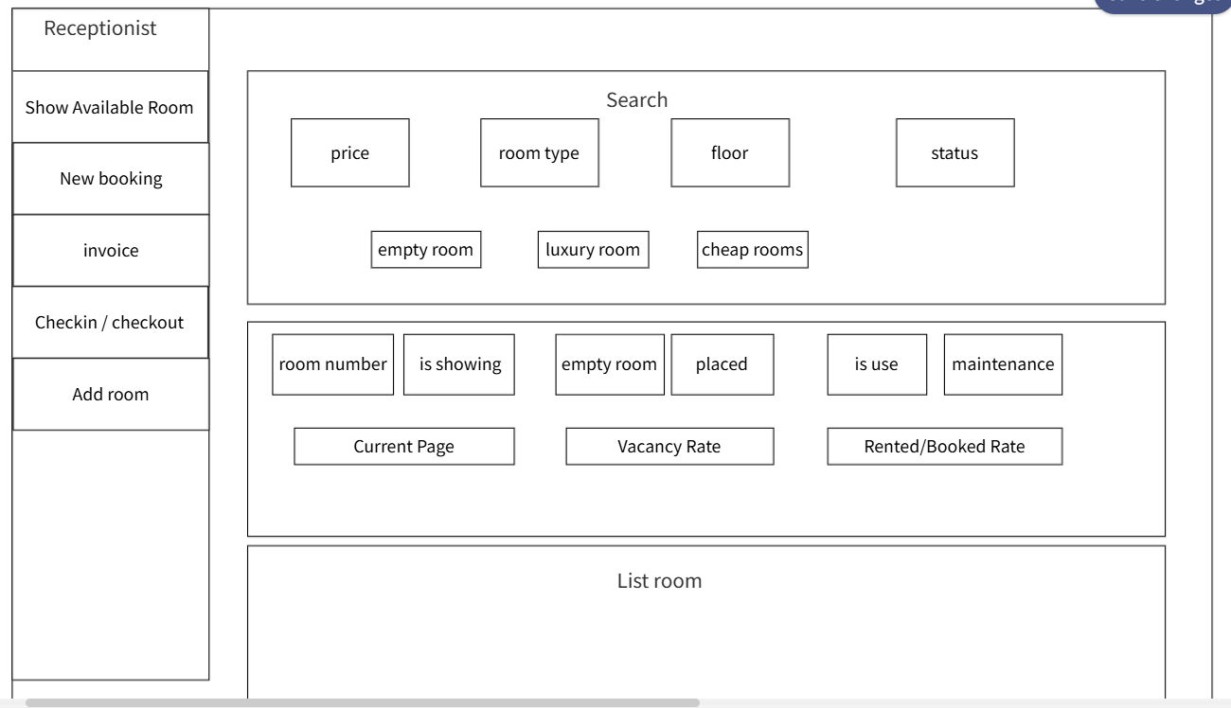

# | Field Name | Type | Mandatory | Max Length | Description
1 | Admin Manager (Title) | Label | No | N/A | Title text of the sidebar menu.
2 | Room Management | Sidebar Button | Yes | N/A | Navigates to the room management section.
3 | Invoice Management | Sidebar Button | Yes | N/A | Navigates to the invoice management page.
4 | Create New Room | Sidebar Button | Yes | N/A | Navigates to the page for creating a new room.
5 | Account Management | Sidebar Button | Yes | N/A | Navigates to the user account management page.
6 | Feedback Management | Sidebar Button | Yes | N/A | Navigates to the feedback management page.
7 | Write Blog | Sidebar Button | No | N/A | Navigates to the blog writing or post management page.
8 | Promotion Management | Sidebar Button | Yes | N/A | Navigates to the promotion management page.
9 | Service Management | Sidebar Button | Yes | N/A | Navigates to the service management page.
10 | Personal Profile | Sidebar Link | No | N/A | Link to view or edit the admin’s personal profile.
11 | Manager Role Label | Label | No | N/A | Label indicating Manager role functionality.
12 | Receptionist Role Label | Label | No | N/A | Label indicating Receptionist role functionality.
13 | Manager Button | Role Button | No | N/A | Indicates current role is Manager.
14 | Receptionist Button | Role Button | No | N/A | Indicates current role is Receptionist.
15 | Welcome, [UserName] | Label | No | N/A | Greeting message displaying the current user’s name.
16 | Log out | Button | Yes | N/A | Button to log out from the admin system.
17 | Empty Room Management | Page Title | Yes | N/A | Title of the current page: empty room management section.
18 | Description below title | Subtitle | No | N/A | A short description shown under the page title.
19 | Booking Information | Info Section | No | N/A | Section containing booking contact details.
20 | Hotline: 0865.124.996 | Contact Label | No | 15 | Phone number for booking inquiries.
21 | Email: support@... | Contact Label | No | 50 | Email address for customer support.
22 | Filter and Search | Section Title | Yes | N/A | Title of the search and filtering section.
23 | Reset | Button | No | N/A | Button to reset all filter/search parameters.
24 | Support Chat Icon | Floating Button | No | N/A | Floating button at the bottom-right for help or chat support.

UC ID and Name: | UC 11 - Homepage Admin (View, Manage)
Created By: | Tran Dinh Huy | Date Created: | 18/6/2025
Primary Actor: | Admin | Secondary Actor: | No
Trigger: | TRG-01: The admin logs into the system.  TRG-02: The admin selects an option from the dashboard menu.
Description: | This function allows the admin to access and manage various hotel operations, such as rooms, services, customers, and amenities, through the dashboard.
Preconditions: | PRE-01: The admin has logged into the system.  PRE-02: The admin has the necessary permissions to access the dashboard.
Postconditions: | The admin successfully accesses the dashboard and its features. The selected data is displayed correctly.  Any performed actions (e.g., filtering data, managing rooms) are successfully applied.
Normal Flow: | The admin logs into the system.  The admin accesses the dashboard.  The admin navigates through the sidebar menu to select a management function (e.g., Room, Service, Customer).  If filtering is needed, the admin enters the start and end date and clicks the "Filter" button.  The system retrieves and displays the filtered data.

Alternative Flows: | If no data matches the filter criteria, the system displays a "No results found" message.
Exceptions: | ● If the admin is not authenticated, the system redirects to the login page.  ● If there is a system error, an error message is displayed.
Priority: | High
Frequency of Use: | Every time an admin logs into the system to manage hotel operations.
Business Rules: | BR1: Only authorized admin users can access the dashboard.  BR2: Data should be displayed in a structured and user-friendly manner.
Other Information: | The dashboard should provide a responsive and intuitive interface for easy navigation.  Important data should be accessible at a glance to improve efficiency.
Assumptions: | The admin has the correct access rights.  The dashboard functions properly and loads the necessary data.

2. Show Available Room

2.1 screen design
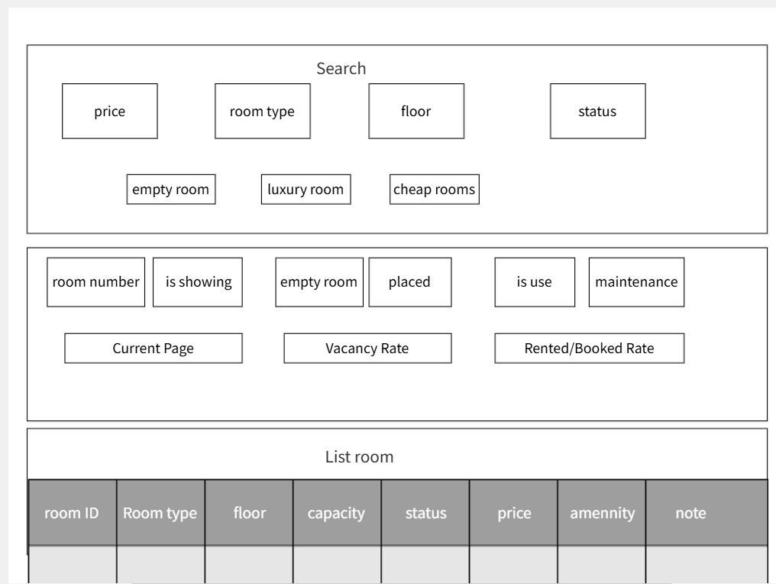

Field Name | Type | Mandatory | Max Length | Description
Admin Manager (Title) | Label | No | N/A | Title text of the sidebar menu.
Room Management | Sidebar Button | Yes | N/A | Navigates to the room management section.
price | Text Input | No | N/A | Filter rooms by price range.
room type | Dropdown | No | N/A | Filter rooms by type (e.g., empty room, luxury room, cheap rooms).
floor | Text Input | No | N/A | Filter rooms by floor number.
status | Dropdown | No | N/A | Filter rooms by status (e.g., is showing, empty room, placed, is use, maintenance).
empty room | Option | No | N/A | Option for room type filter.
luxury room | Option | No | N/A | Option for room type filter.
cheap rooms | Option | No | N/A | Option for room type filter.
room number | Text Input | No | N/A | Display or filter by room number.
is showing | Option | No | N/A | Option for status filter.
empty room | Option | No | N/A | Option for status filter.
placed | Option | No | N/A | Option for status filter.
is use | Option | No | N/A | Option for status filter.
maintenance | Option | No | N/A | Option for status filter.
Current Page | Text Display | No | N/A | Displays the current page number.
Vacancy Rate | Text Display | No | N/A | Displays the vacancy rate.
Rented/Booked Rate | Text Display | No | N/A | Displays the rented/booked rate.
room ID | Text | No | N/A | Identifier for each room in the list.
Room type | Text | No | N/A | Type of room in the list.
floor | Text | No | N/A | Floor number in the list.
capacity | Text | No | N/A | Capacity of the room.
status | Text | No | N/A | Status of the room in the list.
price | Text | No | N/A | Price of the room.
amenity | Text | No | N/A | Amenities available in the room.
note | Text | No | N/A | Additional notes for the room.

UC ID and Name: | UC 01 - Manage Rooms (Search and List)
Created By: | [Your Name]
Date Created: | 25/7/2025
Primary Actor: | receptionist
Secondary Actor: | No
Trigger: | TRG-01: The receptionist logs into the system. TRG-02: The receptionist navigates to the room management page. TRG-03: The receptionist clicks "Search" or views the room list.
Description: | Allows the receptionist to search and view a list of rooms based on various filters and display room details.
Preconditions: | PRE-01: The receptionist has logged into the system. PRE-02: The room data is available in the system.
Postconditions: | The list of rooms is displayed based on search criteria. If a search is performed, the filtered results are shown.
Normal Flow: | 1. The receptionist logs into the system.  2. The receptionist navigates to the room management page.  3. The receptionist views the default room list or enters search criteria (price, room type, floor, status) and clicks "Search".  4. The system displays the list of rooms with details (room ID, room type, floor, capacity, status, price, amenity, note).
Alternative Flows: | AF-01:  1. The receptionist logs into the system.  2. The receptionist navigates to the room management page.  3. The receptionist enters search criteria and clicks "Search".  4. The system displays filtered results.  5. The receptionist changes the "Current Page" to view more results.  AF-02:  1. The receptionist logs into the system.  2. The receptionist navigates to the room management page.  3. The receptionist views the room list.  4. The system displays "Vacancy Rate" and "Rented/Booked Rate".
Exceptions: | If the system fails to load room data, an error message is shown. If no rooms match the search criteria, a "No results found" message is displayed.
Priority: | High
Frequency of Use: | Whenever a receptionist manages room data.
Business Rules: | Receptionists and admin can view and search room data. Room status must be one of: empty room, placed, is use, maintenance.
Other Information: | The system should update "Vacancy Rate" and "Rented/Booked Rate" dynamically based on room status.
Assumptions: | The receptionist has room management permission. All room data is pre-loaded into the system.

3. Manage blog

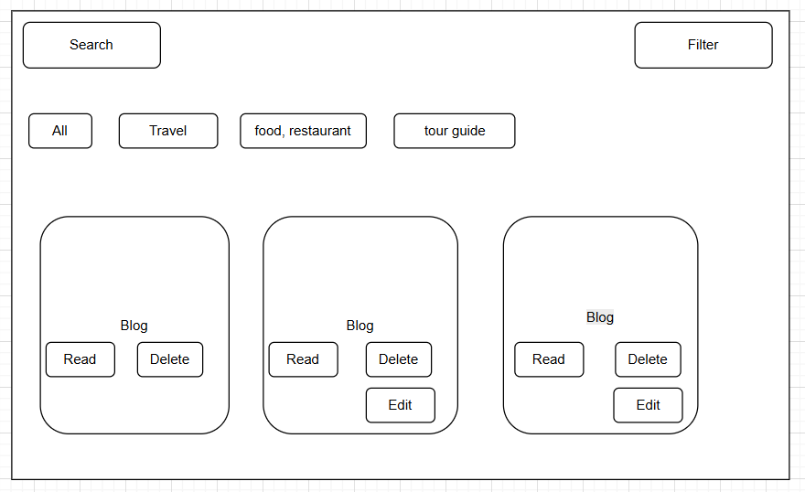

# | Field Name | Type | Mandatory | Max  Length | Description
1 | Title | String | Yes | 500 | Main title of the blog post. Cannot be blank.
2 | Category | Dropdown/Text | Yes | 100 | Available pick list(Dropdown)
3 | Content Blog | Textarea | Yes | N/A | Detailed content of the blog post
4 | Author | Text | No | 100 | Author Name. This field may be auto-filled with the logged in user name.
5 | Dated create | Date Picker | Yes | N/A | Post creation date. Defaults to current date
6 | Choose file | File input | Yes | N/A | Used to upload a thumbnail image for a blog post. Limits the allowed file formats (eg. .jpg, .png).
7 | Status | Radio button | Yes | N/A | The status of the blog post. Includes options: Draft, Published. Default is Draft.
8 | Publish | Button | N/A | N/A | Button to save and publish the blog post.
9 | Cancel | Button | N/A | N/A | .Cancel blog creation
10 | Search | Text | No | N/A | Find blogs by keyword
11 | Filter | Dropdown | No | N/A | Find blogs by filter
12 | Read | Button | No | N/A | Read all details Blog
13 | Edit | button | No | N/A | Edit blog by admin
14 | delete | button | No | N/A | Delete blog by admin

UC ID and Name: | UC 12 - Manage blog (View, Manage)
Created By: | Pham Nguyen | Date Created: | 18/6/2025
Primary Actor: | Admin | Secondary Actor: | No
Trigger: | TRG-01: The admin logs into the system.  TRG-02: The admin go to home page  TRG-03: The admin click “View all blog”
Description: | Allows the admin to view and manage blog posts.
Preconditions: | PRE-01: The admin has logged into the system.
Postconditions: | The blog posts are displayed.  If the admin edit a new blog, it is successfully saved.
Normal Flow: | 1. The admin logs into the system.  2. The admin go to home page  3. The admin clicks "View all blog".  4. The admin edit blog.
Alternative Flows: | AF-1:  1. The admin logs into the system.  2. The admin go to homepage.  3. The admin click “view all blog”  4. The delete blog
Exceptions: | If the system fails to load blogs, an error message is shown.
Priority: | High
Frequency of Use: | Whenever an admin manages blogs.
Business Rules: | Only admins can add or edit blogs.

Other Information | Blogs should have images and descriptions for clarity.
Assumptions: | The admin has blog management permission

4. Manage room
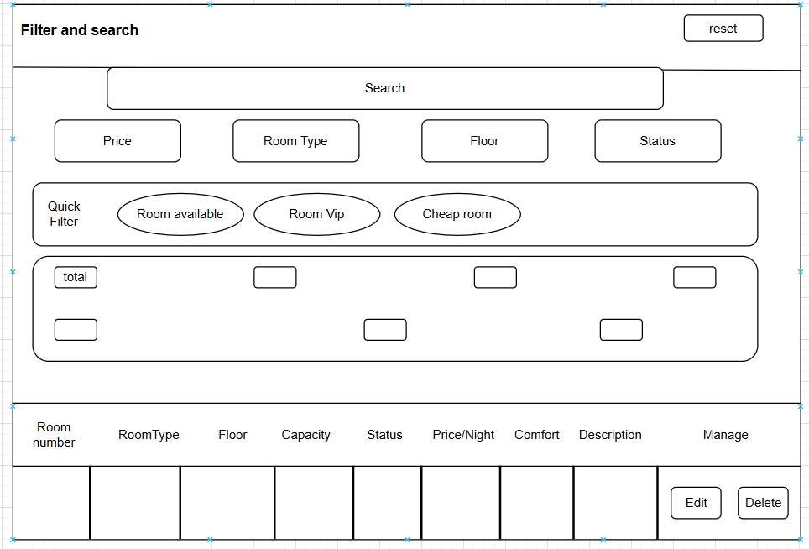

# | Field Name | Type | Mandatory | Max  Length | Description
1 | Dashboard | Label | No | N/A | Title of the dashboard page.
2 | Welcome, Admin | Label | No | N/A | Displays a welcome  message and the user role (Admin).
3 | Log out | Button | Yes | N/A | Button to log out of the system.
4 | Add new room | Button | Yes | N/A | Button to add a new blog post.
9 | Search | Button | No | N/A | Button to search for  rooms based on criteria.
10 | Room List Table | Table | No | N/A | Displays the list of  rooms with details.
11 | Pagination | Navigation | No | N/A | Allows navigation  between pages of room listings.

UC ID and Name: | UC 13 - Manage room (View, Manage)
Created By: | Duong trong luc | Date Created: | 18/6/2025
Primary Actor: | Admin | Secondary Actor: | No
Trigger: | TRG-01: The admin logs into the system.  TRG-02: The admin clicks "Add new room".  TRG-03: The admin performs a search.

Description: Allows the admin to view, add, and search for rooms.
Preconditions: | PRE-01: The admin has logged into the system.
Postconditions: | The room list is displayed.  If a new room is added, it is successfully saved.  If a search is performed, filtered results are shown.
Normal Flow: | 1. The admin logs into the system.  2. The homepage displays the list of rooms.  3. The admin clicks "Add new room" to add a room.  4. The admin enters details and submits.  5. The system saves the room.  6. The admin searches for a room using filters.  7. The system displays filtered results.
Alternative Flows: | If no rooms match the search criteria, the system displays "No results found".
Exceptions: | If the system fails to load rooms, an error message is shown.
Priority: | High
Frequency of Use: | Whenever an admin manages rooms.
Business Rules: | Only admins can add, edit, or delete rooms.
Other Information: | Rooms should have images and status indicators for better clarity.
Assumptions: | The admin has room management permissions.

5. Manage invoice
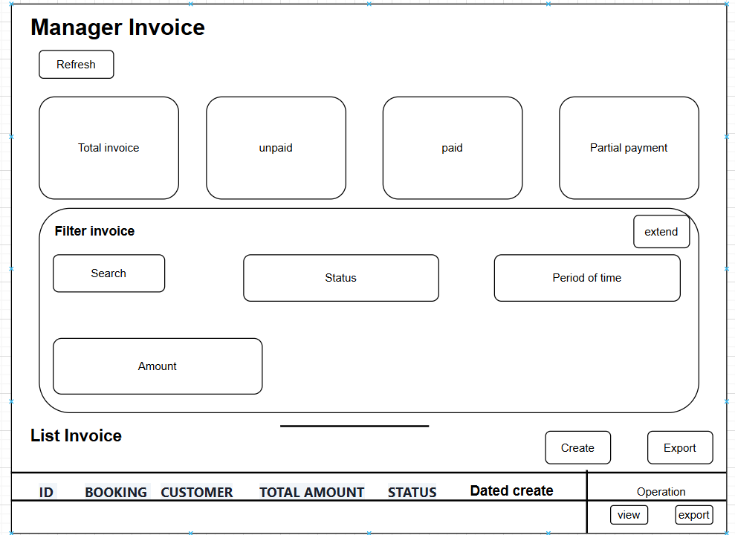

# | Field Name | Type | Mandatory | Max  Length | Description
1 | Refresh | Button | No | N/A | reload page
2 | Total invoice | Card | No | N/A | total bill displayed.
3 | Unpaid | Card | No | N/A | Show total unpaid invoices
4 | Partial payment | Card | No | N/A | Show total number of partial payments
9 | Paid | Card | No | N/A | Show total paid bills
10 | Search | Text | N/A | N/A | search by id , custome
11 | Status | Dropdown | N/A | N/A | Filter by payment status
12 | Period of Time | Dropdown | N/A | N/A | Filter by time period
13 | Amount | Dropdown | N/A | N/A | Filter by amount range
14 | Reset filter | Button | N/A | N/A | Reset filters to default
15 | Export EXCEL | Button | N/A | N/A | Export invoice list to Excel file
16 | ID | Text | N/A | N/A | Invoice ID
17 | BOOKING | Text | N/A | N/A | Booking ID
18 | Customer | Text | N/A | N/A | Name customer
19 | Total amount | Number | N/A | N/A | Total amount of bill
20 | Date created | Date | N/A | N/A | Invoice creation date
21 | View | Button | N/A | N/A | View detail Invoice
22 | Status | Navigation | N/A | N/A | Status of invoice

UC ID and Name: | UC 14 - Manage invoice (View, Manage)
Created By: | Pham Nguyen | Date Created: | 18/6/2025
Primary Actor: | Admin | Secondary Actor: | No
Trigger: | TRG-01: The admin logs into the system.  TRG-02: The admin clicks "Invoice Manger".  TRG-03: The admin click button “extend”  TRG-04: The admin admin search, filter as desired

Description | Allows the admin to view, add, and search for invoices.
Preconditions: | PRE-01: Admin has successfully logged into the system with an account that has invoice management rights.
Postconditions: | The invoice list is displayed according to filters/search.  If a search is performed, filtered results are shown.  If invoices are updated or printed/exported, changes/actions are processed accordingly.
Normal Flow: | 1. Admin logs into the system.  2. System display admin page.  3. Admin selects "Invoice Manager" from the menu.  4. System displays the invoice list with filter/search options.  6. System shows the invoice entry form.  7. Admin uses search/filter to find specific invoices.  8. System displays filtered results.  9. Admin clicks on an invoice to view details.  10. Admin clicks "Print" or "Export" to generate invoice documents.
Alternative Flows: | If no invoice matches the search criteria, the system displays "No results ".
Exceptions: | If the system fails to load an invoice , an error message is shown.
Priority: | High
Frequency of Use: | Whenever an admin manages an invoice .
Business Rules: | Only admins can edit, or print invoices .  Invoice must include customer name and phone number for clarity.  Invoice ID must be unique.  All actions are logged for audit purposes.
Other Information: | Invoice management is critical for business reporting and financial tracking.  Exported invoices should match the current filter/search applied.  The UI should allow sorting by date, amount, customer, and status.
Assumptions: | The admin has invoice management permissions.

6. Manager Account
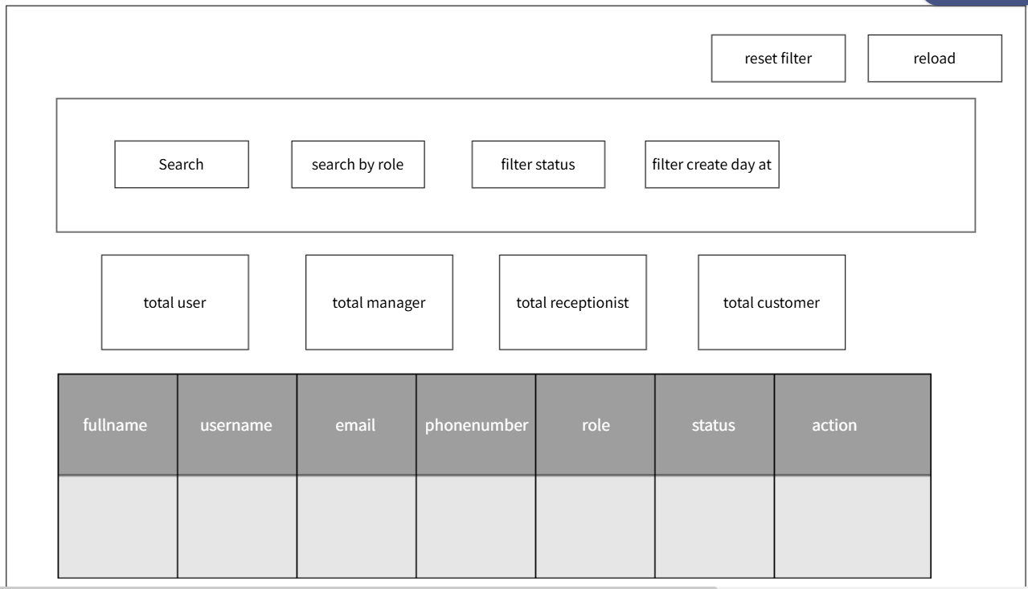
# | Field Name | Type | Mandatory | Max Length | Description
1 | Reset filter | Button | No | N/A | Reset filter
2 | Reload | Button | No | N/A | refresh user list
3 | Search | Text | No | 255 | Allows searching for users by Name, Email, or Username.
4 | Status | Dropdown | No | N/A | Filter user list based on account status.
5 | Filter by permissions | Select/Dropdown | No | N/A | Filter the list of users based on their roles (permissions)..
6 | Date created | Date Picker | No | N/A | Filter users by date account was created.
7 | Total users | overview | N/A | N/A | Number of user account
8 | Manager | overview | N/A | N/A | Number of Manager role
9 | Customer | overview | N/A | N/A | Number of Customer role
10 | Receptionist | overview | N/A | N/A | Number of Receptionist role
11 | Fullname |  |  |  | Full name of user account
11 | Username | Text | Yes | 50 | Username of user account
12 | Email | Email | Yes | 255 | Email of user account
13 | Phone Number | number | No | 15 | User's phone number
14 | Authority At | text | Yes | N/A | Authority at a specific location
15 | Status | text | Yes | N/A | Status of account (work / disable)
16 | Action | action | N/A | N/A | Action of manager (add role and disable / enable)

UC ID and Name: | UC 15 - Manage user (View, Manage)
Created By: | Tran DInh HUy | Date Created: | 18/7/2025
Primary Actor: | Admin | Secondary Actor: | No
Trigger: | TRG-01: Administrator logs into the system.  TRG-02: Administrator clicks "Manage Accounts".  TRG-03: Administrator updates the user list when the filter changes.  TRG-04: Administrator performs the operation of filling in information to search.  TRG-05: Administrator adds role/ deletes role or disables an account
Description: | The system will update the user list when the admin changes the values in the filter or presses the "Refresh" button.  The system will update information about the role or user account status when the admin performs an action.
Preconditions: | The admin is on the "Manage User Permissions" page.
Postconditions: | The list of users will be updated to match the filter criteria.  If there is no matching information the filter will show no matching users.
Normal Flow: | 1. The admin logs into the system.  2. The homepage displays the Admin screen.  3. The admin clicks “Manager Account” on sidebar  4. The system displays the manager account page  5. The system displays the list of users.  6. The admin chooses action (manager role choose permission manager or disable.  7. The admin searches for a user using filters.  8. The system displays filtered results.
Alternative Flows: | No results: Displays the message "No user found".  Clear filters: All filter fields are returned to default values, and the user list is fully reloaded.  System Error: Displays an error message if data cannot be loaded.

Exception: | If the system fails to load users, an error message is show
Priority: | High
Frequency of Use: | Whenever an admin manages users.
Business Rules: | Only admins can edit roles and disable/enable account users.
Inform Information | Other Users should have role-based access control.
Assumptions: | The admin has user management permissions.

7. Manager Service
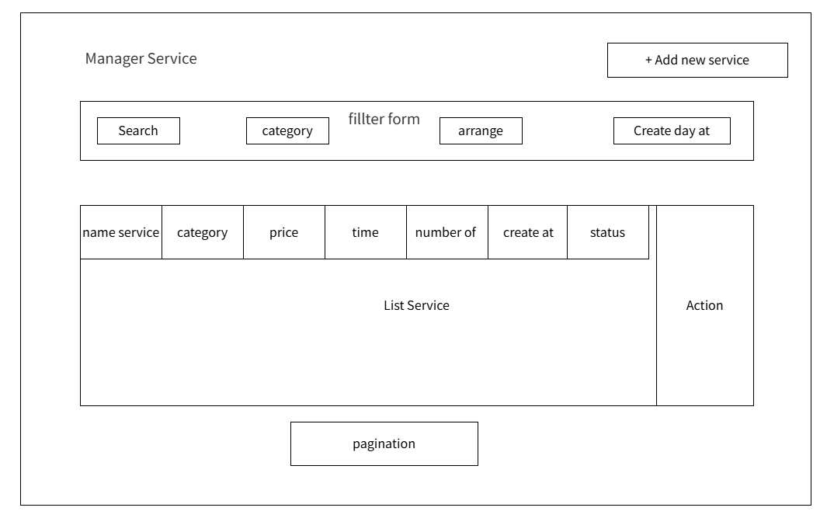

# | Field Name | Type | Mandatory | Max Length | Description
1 | Search by Name | Text | No | N/A | Search field for service name.
2 | Category | Dropdown | No | N/A | Filter by service category
3 | Sort by Price | Dropdown | Yes | N/A | Sort services by price
4 | Creation Date | Date | Yes | N/A | Date when the service was created (mm/dd/yyyy)
5 | Service Name | Text | No | N/A | Name of the service.
6 | Category | Text | No | N/A | Category of the service
7 | Price | Currency |  |  | Price of the service in VND
8 | Duration | Text |  |  | Duration of the service (e.g., 60 minutes)
9 | Number of People | Number |  |  | Number of people the service applies to
10 | Creation Date | Date |  |  | Date when the service was created
11 | Status | Dropdown |  |  | Status of the service (Active/Inactive)
12 | Action | Action |  |  | Actions to perform (Edit/DetailDelete)

UC ID and Name: | UC16 - Manage service (View, Manage)
Created By: | Tran DInh Huy | Date Created: | 18/7/2025
Primary Actor: | Admin | Secondary Actor: | No
Trigger: | TRG-01: The admin logs into the system.  TRG-02: The admin clicks "Add Service".  TRG-03: The admin clicks "Edit Service".  TRG-04: The admin clicks "Delete Service".  TRG-05: The admin performs a search.  TRG-06: The admin selects a sorting option.
Description: | Allows the admin to view, add, edit, delete, search, and sort services.
Precondition | PRE-01: The admin has logged into the system

Postconditions: | The service list is displayed.  If a new service is added, it is successfully saved.  If edit service, it is successfully saved  If delete service, database successfully saved  If a search is performed, filtered results are shown.  If a sorting option is selected, services are displayed in the chosen order.
Normal Flow: | 1. The admin logs into the system.  2. The homepage displays the Available Room.  3. The admin clicks “Manager Service” on sidebar  4. The system displays the manager service page  5. The admin clicks "Add Service" to add a new service.  6. The admin enters service details and submits.  7. The system saves the new service.  8. The admin searches for a service using filters.  9. The system displays filtered results.  10. The admin selects a sorting option from the "Sort by" dropdown.  11. The system updates the displayed list accordingly.  12. The admin clicks edit service.  13. The admin edit service information.  14. The system update service in database successfully and displays list service  15. The admin clicks delete service.  16. The system displays a notification “Are you sure you want to delete this service?”  17. The admin clicks ok.  18. The system reload and update list service, displays notify “delete successfully”
Alternative Flows: | If no services match the search criteria, the system will display "No services available".
Exceptions: | - If the system fails to load services, an error message is shown.  - If the system fails to edit the service, an error message is shown.  - If the admin fails to add the service (for example, leaving the service name information blank, ..., or the number of users/time of use/price is 0, a notification will appear asking for input.
Priority: | High
Frequency of Use: | When ever an admin manages services.
Business Rules: | Only admins can add, edit, or delete services.
Other Information: | Services should be categorized properly.
Assumptions: | The admin has service management permissions.

8. Manage Booking

8.1.1 Screen Design

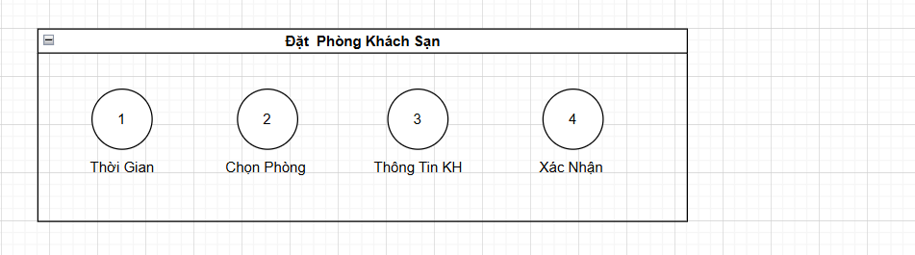

..
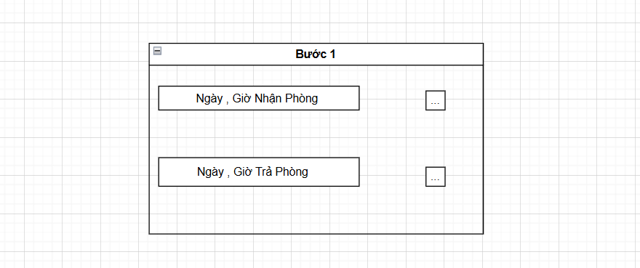

# | Field Name | Type | Mandatory | Max Length | Description
1 | Check-in Date | Date | Yes | N/A | The date when the customer will check in
2 | Check-in Time | Time | Yes | N/A
  The time when the customer will check in
3 | Check-out Date | Date | Yes | N/A | The date when the customer will check out
4 | Check-out Time | Time | Yes | N/A | The time when the customer will check out

8.1.2 Use Case Specification

UC ID and Name: | UC 17 - Booking Room at Reception
Created By: | Dương Trọng Lực | Date Created: | 17/6/2025
Primary Actor: | Receptionist | Secondary Actor: | None
Trigger: | TRG-01:The receptionist wants to enter check-in and check-out dates to continue the room booking process for the guest.

Description | The receptionist enters the check-in and check-out dates into the system. The system will validate the dates (check-out must be after check-in, and neither date may be in the past). This is the first step in the offline booking flow at the front desk.
Preconditions: | PRE-01: The system is currently displaying the front-desk booking interface.  PRE-02: Room status data (available/booked) has been synchronized.
Postconditions: | POST-1: Valid check-in and check-out dates are temporarily saved.  POST-2: The system filters and displays available rooms for the selected date range.
Normal Flow: | Enter Check-in and Check-out Dates  1. The system displays a form to input check-in and check-out dates.  2. The receptionist enters the check-in and check-out dates.  3. The system checks the validity of the date range  4. The system ensures the dates are not in the past.  5. The system verifies that check-out is after check-in.  6. The system displays a list of rooms available for the selected dates.
Alternative Flows: | AF1 : Quick input with Today and Tomorrow  -The receptionist clicks the "Set Default: Today - Tomorrow" button.  -The system auto-fills check-in as today and check-out as tomorrow.  - Return to step 3 of the Normal Flow.
Exceptions: | E1: Check-out date is earlier than or equal to check-in date  -The system displays an error: “Check-out date must be after check-in date.”  -Return to step 2 to re-enter the dates.  E2: Entered dates are in the past  -The system displays an error: “Cannot select dates in the past.”  -Return to step 2 to re-select valid dates.
Priority: | High
Frequency of Use: | This is a required step to accurately filter available rooms.
Business Rules: | BR1: Check-in date must not be earlier than the current date.  BR2: Check-out date must be at least 1 day after the check-in date.  BR3: The system uses the current time based on Vietnam timezone.  BR4: Any change to the dates triggers a re-filtering of available rooms.
Other Information: | Holidays or peak seasons may show additional alerts for receptionist attention.  A calendar popup (date picker) may be integrated to speed up the date selection.
Assumptions: | The receptionist is trained to understand the date input format and business rules.

8.2.1 Screen Design
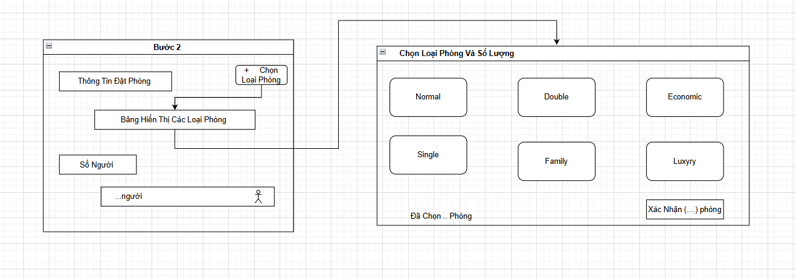

# | Field Name | Type | Mandatory | Max Length | Description
1 | Booking Information | Label | Yes | 255 | Display general booking info: check-in/out date, number of nights, guests
2 | Room Type Selection Form | Label | Yes | N/A | Section that appears after clicking to choose room type
3 | Room Type List | Label | Yes | N/A | List of available room types (Normal, Double, Single, etc.) to select
4 |  | Number | Yes | N/A
  Quantity per Room Type
  Input number of rooms for each selected room typ
5 | Number of Guests | Number | Yes | 100 | Input total number of guests
6 | Rooms Selected | Label | Yes | N/A | Display total rooms selected
7 | Confirm (.. rooms selected) | Button | Yes
  Confirm the selected room types and quantities

8.2.2 Use Case

UC ID and Name: | UC 17.1 - Select Room & Enter Number of Guests
Created By: | Dương Trọng Lực | Date Created: | 18/6/2025
Primary Actor: | Receptionist | Secondary Actor: | None
Trigger: | TRG-01: The receptionist has entered the check-in and check-out dates and wants to find available rooms and select a suitable one for the guest.

Description | This use case describes how the receptionist searches for available rooms based on the requested dates, selects a suitable room, and enters the number of guests.
Preconditions: | PRE-1: Valid check-in and check-out dates have been entered.  PRE-2: The system is connected to the room database.
Postconditions: | POST-1: The selected room is temporarily assigned to the booking (not yet confirmed).  POST-2: The number of guests is temporarily saved.
Normal Flow: | Receptionist selects a room and enters number of guests  1. The system displays a list of available rooms for the selected dates.  2. The receptionist browses/filters the list and selects a suitable room.  3. The system shows the room details and prompts for the number of guests.  4. The receptionist enters the number of guests (e.g., 2).  5. The system checks that the number does not exceed the room's capacity.  6. The system temporarily saves the selection and proceeds to guest information entry.
Alternative Flows: | AF1 Number of guests exceeds room capacity  The system shows an error: “The number of guests exceeds room capacity.”  ->Return to step 4 to re-enter the number.  .
Exceptions: | E1 - The system displays: “Room system connection error. Please try again.”  The receptionist retries later or contacts the manager.
Priority: | High – This is a critical step to determine guest needs and choose a suitable room.
Frequency of Use: | Whenever this is a critical step to determine guest needs and choose a suitable room.
Business Rules: | BR1: Only rooms available for the selected dates are displayed.  BR2: Room capacity must be validated (e.g., maximum 4 adults).  BR3: Number of guests must be a positive integer.
Other Information: | The system may suggest rooms based on the number of guests.  Filtering by room type or amenities can be added as a feature.
Assumptions: | Guests do not need to provide personal information at this stage, only required to select a room and enter the number of people.

8.3.1 Screen Design
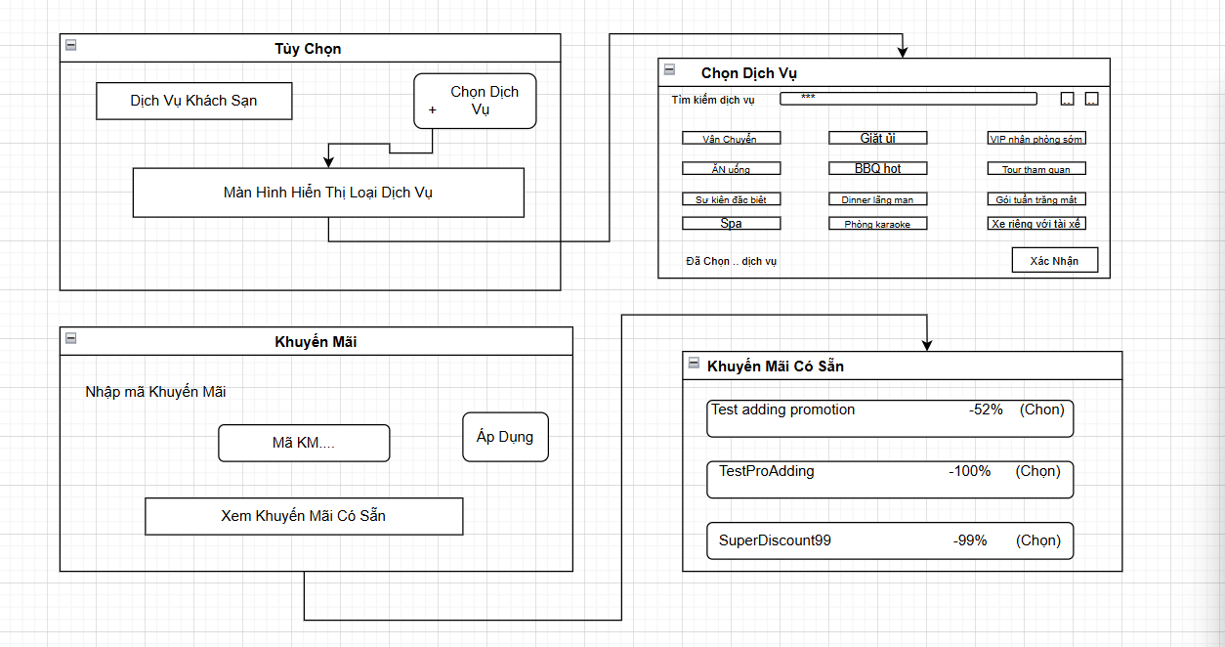

# | Field Name | Type | Mandatory | Max Length | Description
1 | Choose Service | Button | Yes | N/A | screen showing service types
2 | Search | Text | No | N/A | Search by key
3 | Service Name | Button | No | N/A | Types of services available
4 | Submit | Date | Yes | N/A | Confirm service selection
5 | Service Name | Text | No | N/A | Name of the service.
6 | Promotion code | Text | No | N/A | discount code
7 | Apply | Button | Yes | N/A | Apply discount code at checkout
8 | View available promo codes | Text | No | N/A | Discount codes available
9 | Discount number | Button | Yes | 100 | User choose Discount

8.3.2 Use Case Specification

UC ID and Name: | UC 17.2 - Select Services and Apply Promotion
Created By: | Dương Trọng Lực | Date Created: | 18/6/2025
Primary Actor: | Receptionist | Secondary Actor: | None
Trigger: | TRG-01: The user wants to select additional services and apply for a promotion during the room booking process.

Description | This use case describes the flow where the user selects one or more hotel services (e.g., spa, transportation, BBQ...) and either enters a promo code manually or selects one from a list to receive the corresponding discount.
Preconditions: | PRE-1: The user is logged in and currently in the booking flow.  PRE-2: The list of services and available promotions is preloaded from the system.
Postconditions: | POST-1: The selected services are saved to the booking record.  POST-2: The promotion code is successfully applied (if any) and the total amount is updated.
Normal Flow: | Select Services and Apply Promotion  - The user navigates to the "Select Services" page.  - The system displays a list of services:  Early VIP check-in, City tour, Dining, Spa, Laundry, BBQ, Private car, etc.  - The user selects one or more services.  - The system displays the selected services in the "Selected Services (... items)" section.  - The user can either:  -Enter a promotion code manually, or  -Click “View Available Promotions” to choose from a list:  +Test adding promotion (-52%)  +SuperDiscount99 (-99%)  - The user clicks “Select” for a promotion and then clicks “Apply”.  - The system validates the promo code and applies it to eligible services.  - The system updates the total amount and shows the applied discount.  - The user clicks “Confirm” to save the selected services and promotion.
Alternative Flows: | E1: No services selected  -The system displays a warning: “You haven’t selected any service”, but still allows proceeding.  E2: Empty promotion code input  -The system displays: “Please enter a promotion code or select from the available list.”  E3: Invalid or expired promotion code  -The system displays: “Invalid or expired promotion code.”  E4: Promotion code not applicable to selected services  -The system displays: “This promotion code does not apply to the selected services.”  E5: Connection error while applying promotion code  -The system displays: “Unable to connect to validate the promotion code. Please try again later.”
Exceptions: | E1: Promotion code system unavailable  E2: Services database not loaded  E3: UI rendering failure for services or promotions
Priority: | High
Frequency of Use: | Whenever this use case is expected to be used frequently during room booking, especially during holiday seasons and major promotions.
Business Rules: | BR1: Each promotion code is valid only for specific services.  BR2: Only one promotion code can be applied at a time.  BR3: Promotion code format: [letters + numbers], case-insensitive (e.g., SuperDiscount99).  BR4: If multiple valid codes are selected simultaneously, the system prioritizes the one with the highest discount.  BR5: All error messages appear below the respective input fields in red.
Other Information: | Expected to be frequently used during the booking process, especially during peak travel seasons and promotional campaigns.
Assumptions: | -The promotion validation API is always available.  -Service and promotion data is always up to date.  -The user understands how promotions work and can identify suitable offers.

8.4.1 Screen Design
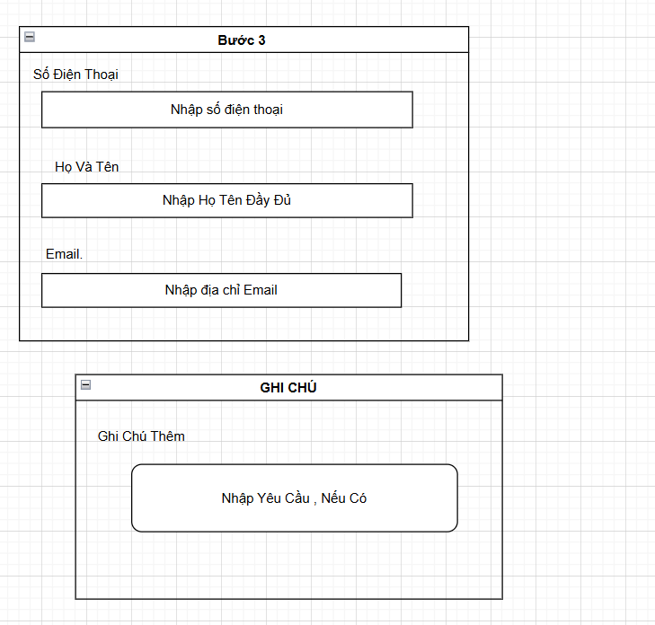
# | Field Name | Type | Mandatory | Max Length | Description
1 | PhoneNumber | Text | Yes | 50 | Enter the customer's phone number (numeric only)
2 | fullName | Text | Yes | 150 | Enter the customer's full name
3 | EmailAddress | Email | Yes | 150 | Enter a valid Email address
4 | NoteTitle | Label | No | N/A
  Label displaying “Additional Note”
5 | AdditionalRequest | Text | No | 255 | Enter additional requests, if any

8.4.2 Use Case Specification

UC ID and Name: | UC 17.3- Enter Contact Information
Created By: | Dương Trọng Lực | Date Created: | 20/6/2025
Primary Actor: | Receptionist | Secondary Actor: | None
Trigger: | TRG-01: The user proceeds to the contact information step during the room booking process.

Description | This use case describes the process where the user inputs their contact details including phone number, full name, email address, and additional notes if any.
Preconditions: | PRE-1: The user has selected room types and quantities in the previous step.  PRE-2: The system has navigated to the contact information form.
Postconditions: | POST-1: The system saves the contact information for the booking request.  POST-2: Validated data is passed to the next confirmation or payment step.
Normal Flow: | Enter Contact Information  - The system displays input fields for:  -Phone Number (Please fill out this file)  -Full Name (Please fill out this file)  -Email (Please fill out this file)  -Additional Notes  - The user fills in the required fields.  - The user optionally adds additional notes.  - The system validates all inputs:  -The phone number is in the correct numeric format.  -Email is in the correct email format.  -Full name is not empty.  - The system saves the contact information and proceeds to the next step.
Alternative Flows: | E1: Empty required fields  → The system highlights the missing fields and shows messages like “Phone number is required”, “Full name cannot be empty”.  E2: Invalid phone number format  → The system shows: “Please enter a valid phone number”.  E3: Invalid email format  → The system shows: “Please enter a valid email address”.
Exceptions: | -E1 System fails to save contact data  -E2 Internet connection lost during form submission  -E3 Field rendering issues on mobile devices
Priority: | High
Frequency of Use: | Whenever every booking requires user contact details to be filled.
Business Rules: | BR1: Phone number must be 10–15 digits, numbers only.  BR2: Full name must contain letters and can include accents.  BR3: Email must follow standard email format  (e.g., abc@example.com).  BR4: Additional notes are optional, with a max length of 255 characters.
Other Information: | The “Notes” field allows users to add special requests (such as requesting a higher floor room, extra bed…), which are sent to the front desk.
Assumptions: | -The user has a valid email and phone number.  -The form supports international formats (for phone and email).  -All data is stored securely and complies with data protection policies.  .

8.5.1 Screen Design
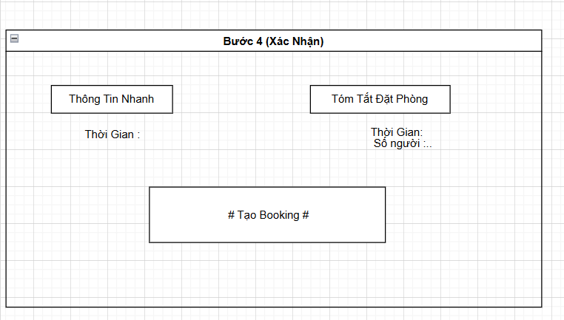

# | Field Name | Type | Mandatory | Max Length | Description
1 | Quick Information | Label | Yes | N/A | Title of the section displaying brief booking info
2 | Time: (in Quick Information | Label | Yes | N/A | Label “Time:” followed by the check-in and check-out dates (e.g., 25/7–26/7/2025)
3 | Booking Summary | Label | Yes | N/A
  Title of the section displaying detailed booking info
4 | Time: (in Booking Summary) | Label | Yes | N/A | Label “Time:” showing the full date range
5 | Number of Guests: | Label | Yes | N/A | Label showing the number of guests (e.g., 1 guest)
6 | Create Booking | Button | Yes | N/A | Button to confirm and create the booking

8.5.2 Use Case

UC ID and Name: | UC 17.4 - Confirm Booking
Created By: | Dương Trọng Lực | Date Created: | 23/6/2025
Primary Actor: | Receptionist | Secondary Actor: | None
Trigger: | TRG-01:The user has completed selecting rooms, services, and promotions, and wants to confirm to create an official booking.

Description | This use case describes the process where the user reviews booking information, confirms the details (time, number of guests, services...), and clicks “Create Booking” to save the booking into the system.
Preconditions: | PRE-1: The user has selected valid rooms and check-in/check-out dates.  PRE-2: The user has selected (or skipped) services and promotion codes.  PRE-3: Number of guests and length of stay are valid.
Postconditions: | POST-1: The system creates a new booking and saves it into the database.  POST-2: The user receives a confirmation message (optionally with a booking ID).
Normal Flow:
  Confirm and Create Booking
  + The system displays the “Booking Confirmation” screen including:
  -Stay duration (check-in/check-out)
  -Number of guests
  -Summary of selected services and applied promotions (if any)
  -Total cost (if applicable)
  +The user reviews all information.
  +The user clicks “Create Booking”.
  +The system validates the data:
  - Valid check-in/check-out dates
  - Room availability
  - Number of guests within room capacity
  - Promotion code is still valid
  + If all data is valid, the system:
  - Creates a new booking
  - Assigns a unique booking ID
  - Saves the information
  - Displays: “Booking successful!”
Alternative Flows: | E1: Room is no longer available  → System shows: “Selected room is no longer available. Please choose another one.”  E2: Invalid check-in/check-out dates  → System shows: “Invalid date. Please review your selection.”  E3: Number of guests exceeds room capacity  → System shows: “The number of guests exceeds the limit for the selected room type.”  E4: Promotion code is expired  → System removes the code and shows: “Promotion code has expired or is no longer applicable.”  E5: System or network error during booking creation  → System shows: “Unable to create booking at this time. Please try again later.”
Exceptions: | -E1: The system may encounter concurrency issues if multiple users try to book the same room at the same time.  -E2: Data inconsistency can occur if promotions are updated or expired while the user is still reviewing the summary screen.  -E3: Session timeout if the user stays idle too long before confirming.
Priority: | High
Frequency of Use: | This use case is expected to be used frequently, especially during peak seasons (holidays, weekends).
Business Rules: | BR1: Each room type has a guest capacity limit. System must validate this.  BR2: Every booking must have valid check-in and check-out dates.  BR3: Booking ID must be unique within the system.  BR4: Booking can only be created if the room status is “available” at confirmation.  BR5: Even without any selected service or promotion, a booking can still be created.
Other Information: | This is the final step in the booking process and impacts room availability.  Errors related to unavailable rooms should be handled promptly and the user redirected appropriately.
Assumptions: | -The user has a stable internet connection during the confirmation process.  -Room and promotion data are synchronized and up-to-date at the time of confirmation.  -The user has reviewed and agreed to the booking terms and conditions.

9. Manage Feedback Manage
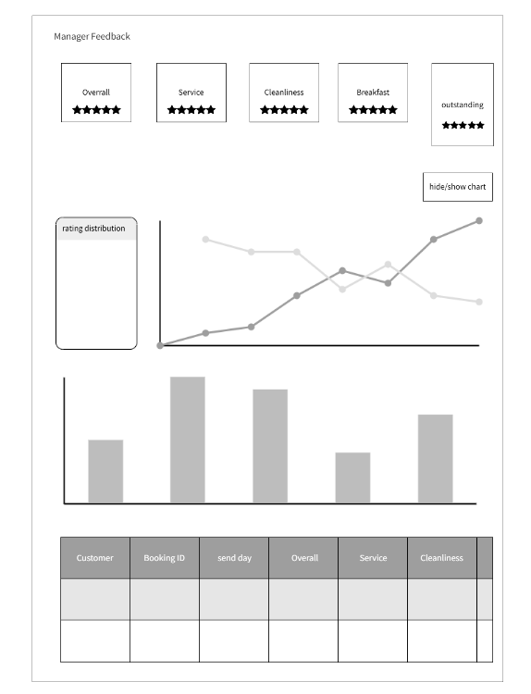

# | Field Name | Type | Mandatory | Max Length | Description
1 | Feedback Manage | Label | No | N/A | Title of the feedback  management page.
2 | Guest Feedback List | Label | No | N/A | Subtitle of the feedback management page.
4 | Feedback Table | Table | No | N/A | Displays guest feedback details.

UC ID and Name: | UC 18 - Manage Feedback (View, Manage)
Created By: | Vo Hoang Phuc | Date Created: | 18/6/2025
Primary Actor: | Admin | Secondary Actor: | No
Trigger: | TRG-01: The admin logs into the system.  TRG-02: The admin accesses the "Feedback Manage" page.  TRG-03: The admin clicks "Guest Feedback List".
Description: | Allows the admin to view guest feedback and highlight feedback(s) to display it in home page
Preconditions: | PRE-01: The admin has logged into the system.
Postconditions: | The feedback list is displayed. Highlighted feedback(s) shown in home page
Normal Flow: | 1. The admin logs into the system.  2.The admin navigates to the “Feedback Manager”  3. The system displays the feedback table.  4. Admin view feedback(s)’s statistics

Alternative Flows: | - If no feedback is available, the table remains empty.  - Admin clicks the “highlight” button to highlight feedback(s) which he/she wants its/them to be shown on the home page .
Exceptions: | If the system fails to load feedback, an error message is shown.
Priority: | High
Frequency of Use: | Whenever an admin needs to monitor feedback.
Business Rules: | Only admins can access guest feedback details.
Other Information: | Feedback data should be updated in real time.
Assumptions: | The admin has feedback management permissions.

10. Manager Promotion

10.1. Manage Promotion
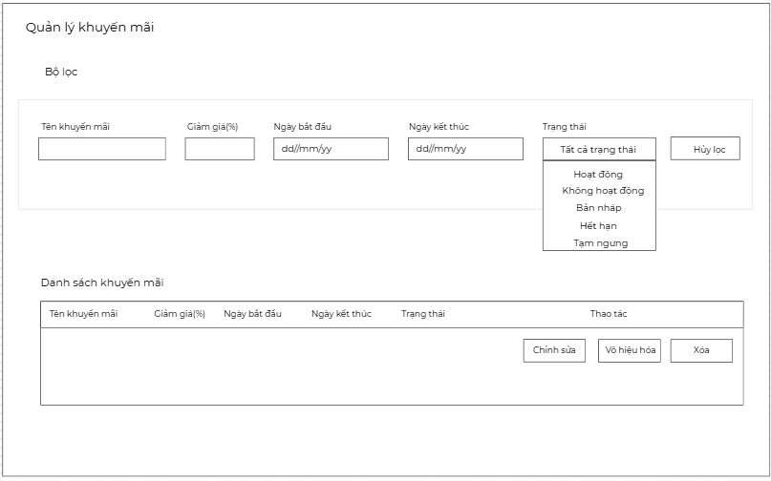

# | Field Name | Type | Mandatory | Max  Length | Description
1 | Promotion Name | Textbox | Yes | 100 | Name of the promotion campaign  (e.g., Summer Sale).
2 | Discount  Percentage (%) | Float | Yes | 3 | Discount percentage applied to the  booking (e.g., 10, 15, 50).
3 | Start Date | Date | Yes | N/A | The date the promotion becomes  effective.
4 | End Date | Date | Yes | N/A | The date the promotion expires.
5 | Status | Dropdown | Yes | N/A | Indicates whether the promotion is Active, Inactive,  Draft, or Expired.
6 | Description | Textarea | No | 300 | Detailed description of the promotion.
7 | Is Immediately  Usable | Checkbox | No | N/A | Whether the promotion can be  applied immediately once it’s  within valid time.
8 | Filter – Promotion  Name | Textbox | No | 100 | Filter the list by promotion name.
9 | Filter – Discount  (%) | float | No | 3 | Filter the list by discount percentage.
10 | Filter – Start Date | Date | No | N/A | Filter promotions starting from this  date.
11 | Filter – End Date | Date | No | N/A | Filter promotions ending before  this date.
12 | Filter – Status | Dropdown | No | N/A | Filter promotions by status (All,  Active, Inactive, Draft, Expired).
13 | Refresh Button | Button | No | N/A | Refreshes the list of promotions.
14 | Add New  Promotion Button | Button | No | N/A | Opens the form to create a new  promotion.
15 | Delete Filter Button | Button | No | N/A | Clears all filter fields.

Item | Details
UC ID and Name | UC 19 - Manage Promotion List (View, Create, Edit)
Created By | Vo Hoang Phuc
Created Date | 24/06/2025
Primary Actor | Admin
Secondary Actor | None
Trigger Events | - TRG-01: Admin accesses "Promotion Management" screen- TRG-02: Admin clicks "Add New Promotion"- TRG-03: Admin uses filters or updates status
Description | Allows the admin to manage hotel promotions including creating, editing, and viewing.
Preconditions | PRE-01: Admin must be logged in with the appropriate permissions.
Postconditions | - Promotion list is displayed or updated- New promotion added successfully
Normal Flow | 1. Admin navigates to Promotion Management  2. Promotions summary is shown  3. Admin filters or views promotions  4. Admin clicks “Add New Promotion”  5. Admin fills in form and submits. New promotion appears in the list
Alternative Flow | - If no promotions exist, a message is shown with a prompt to add the first one
Exception Flow | - If form validation fails, appropriate error messages are displayed
Priority | Medium to High
Frequency of Use | Whenever a new promotion is to be created or managed
Business Rules | - Promotions must have valid dates and discount %- Status determines visibility and usability
Other Information | - Expired promotions should automatically change status
Assumptions | Admin has full control over promotions and sees real-time data

10.2. Add new promotion

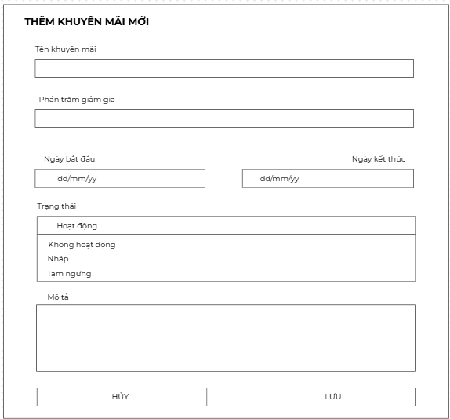

# | Field Name | Type | Mandatory | Max  Length | Description
1 | Promotion  Name | Textbox | Yes | 100 | Name of the promotion campaign  (e.g., Summer Sale).
2 | Discount  Percentage (%) | Float | Yes | 3 | Discount percentage applied to the  booking.
3 | Start Date | Date | Yes | N/A | The date the promotion becomes  effective.
4 | End Date | Date | Yes | N/A | The date the promotion expires.
5 | Status | Dropdown | Yes | N/A | Indicates whether the promotion is  Active, Inactive, Draft, or Expired.
6 | Description | Textarea | No | 300 | Detailed description of the promotion.

Item | Details
UC ID and Name | UC 41 - Manage Promotion List (View, Create, Edit)
Created By | Vo Hoang Phuc
Created Date | 24/06/2025
Primary Actor | Admin
Secondary Actor | None
Trigger Events | - Admin wants to create a new promotion to apply discounts for customers.
Description | This use case describes the process of adding a new promotion into the system by the admin, including necessary information such as name, discount percentage, duration, status, and description.
Preconditions | PRE – 1: The admin is logged in and navigates to the "Add Promotion" page.
Postconditions | POST – 1: A new promotion is created and saved into the system.
Normal Flow | 1.0: Add a new promotion  - The admin clicks the button “Add new promotion” in the Promotion manager page.  - The system displays the "Add New Promotion" form.  - The admin fills in all mandatory fields: Promotion Name, Discount Percentage, Start Date, End Date, Status, description.  - Optionally, the admin enters a description.  - The admin clicks the "Save" button.  - The system validates the data.  - If all data is valid, the system saves the promotion.  - The system displays a success message indicating the promotion was created.
Alternative Flow | 1.1: Cancel promotion creation  - At any point, the admin clicks the "Cancel" button.  - The system clears the form or navigates back to the promotion list.  - No promotion is saved.
Exception Flow | 1.0.E1: Mandatory fields are left blank  - The system notifies: “{Field Name} is required.”  - Return to step 3 of the Normal Flow.  1.0.E2: Discount Percentage is invalid  - The system notifies: “Discount must be between 1 and 100.”  - Return to step 3.  1.0.E3: End Date is before Start Date  - The system notifies: “End Date must be later than Start Date.”  - Return to step 3.
Priority | Medium to High
Frequency of Use | Whenever a new promotion is to be created or managed
Business Rules | BR1: Promotion Name is required, max 100 characters.  BR2: Discount must be between 1 and 100.  BR3: Start and End Dates must be in valid format (dd/mm/yyyy).  BR4: Status must be one of: Active, Inactive, Draft, Suspended.  BR5: Description is optional, max 500 characters.
Other Information | - Promotion may be used in filtering logic on booking pages.  - Admin can later edit or delete the promotion.  - The promotion should not be applied before the start date or after the end date.
Assumptions | Admin has full control over promotions and sees real-time data

10.3. Update promotion
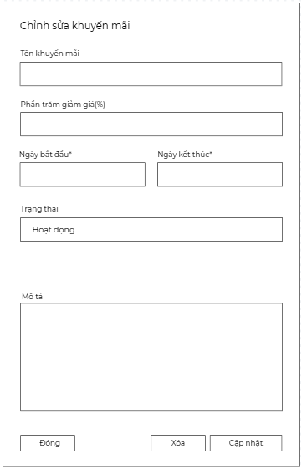

# | Field Name | Type | Mandatory | Max  Length | Description
1 | Promotion  Name | Textbox | Yes | 100 | Name of the promotion campaign  (e.g., Summer Sale).
2 | Discount  Percentage (%) | Float | Yes | 3 | Discount percentage applied to the  booking.
3 | Start Date | Date | Yes | N/A | The date the promotion becomes  effective.
4 | End Date | Date | Yes | N/A | The date the promotion expires.
5 | Status | Dropdown | Yes | N/A | Indicates whether the promotion is  Active, Inactive, Draft, or Expired.
6 | Description | Textarea | No | 300 | Detailed description of the promotion.

Item | Details
UC ID and Name | UC 42 - Update Promotion
Created By | Vo Hoang Phuc
Created Date | 24/06/2025
Primary Actor | Admin
Secondary Actor | None
Trigger | The admin wants to update existing promotion details.
Description | This use case describes the process where an admin edits the information of an existing promotion, including name, discount percentage, start and end date, status, and description.
Preconditions | 1. The admin is logged in to the system.  2. At least one promotion already exists in the system..
Postconditions | - The promotion information is updated in the system.  - The updated promotion appears in the promotions list.
Normal Flow | 1.0: Add a new promotion  - The admin clicks the button “Update promotion” in the Promotion manager page.  - The system displays the "Update Promotion" form.  - The admin changes in all mandatory fields need update  - The admin clicks the "Save" button.  - The system displays a success message indicating the promotion was created.
Alternative Flow | 1.1: Cancel promotion creation  - the admin clicks the "Cancel" button.  - The system clears the form or navigates back to the promotion list.  - No promotion is updated.
Exception Flow | - The system notifies: promotion name is not blank.  - The discount value is not a number or not between 0–100.  - The start date is later than the end date.
Priority | Medium to High
Business Rules | BR1: Promotion Name is required, max 100 characters.  BR2: Discount must be between 1 and 100.  BR3: Start and End Dates must be in valid format (dd/mm/yyyy).  BR4: Status must be one of: Active, Inactive, Draft, Suspended.  BR5: Description is optional, max 500 characters.

10.4. Inactive Promotion

Item | Details
UC ID and Name | UC 43 - Inactive Promotion
Created By | Vo Hoang Phuc
Created Date | 24/06/2025
Primary Actor | Admin
Secondary Actor | None
Trigger | The admin wants to inactive an active promotion.
Description | This use case allows an admin to change the status of a currently active promotion to inactive
Preconditions | - The admin is logged into the system.  - The promotion has a current status of "Active".
Postconditions | - The promotion status is updated to "Inactive".  - The promotion is no longer applicable in customer transactions.
Normal Flow | 1.The admin clicks the button “Inactive promotion” in the Promotion manager page.  2.The system prompts the admin for confirmation: “Are you sure you want to deactivate this promotion?”  3.The admin choose yes  4.The system updates the promotion’s status to “Inactive” in the database  5.The updated status is reflected in the promotion list.
Alternative Flow | - the admin clicks “Cancel” in the confirmation dialog.  - The system aborts the deactivation process.  - No changes are made; the promotion remains Active.
Exception Flow | - The promotion is already Inactive or Expired.
Priority | Medium
Business Rules | BR1: Only promotions with status Active can be deactivated.  BR2: Deactivation requires confirmation from the admin.  BR3: Only users with “Promotion Management” privileges can perform this action.

10.5 . Delete Promotion

Item | Details
UC ID and Name | UC 44 - Delete Promotion
Created By | Vo Hoang Phuc
Created Date | 24/06/2025
Primary Actor | Admin
Secondary Actor | None
Trigger | The admin wants to delete the promotion.
Description | This use case allows an admin to remove an existing promotion from the system when it  is no longer needed or was created by mistake.
Preconditions | - The admin is logged into the system.  - The promotion to be deleted exists and is not associated with active bookings.
Postconditions | The selected promotion is removed from the database
Normal Flow | 1.The admin locates the promotion to delete and clicks the “Delete” button in the Promotion manager page.  2.The system displays a confirmation dialog: “Are you sure you want to delete this promotion?”  3.The admin choose yes  4.The system deletes the promotion from the database  5.A success message is displayed: “Promotion deleted successfully.”  6.The updated promotion list is displayed, excluding the deleted item.
Alternative Flow | - the admin clicks “Cancel” in the confirmation dialog.  - The system aborts the deactivation process.  - The promotion remains unchanged and still appears in the list.
Exception Flow | - The selected promotion no longer exists or has already been deleted.  - The promotion is currently in use or associated with active reservations.
Priority | Medium
Business Rules | BR1: Only promotions not linked to current or upcoming bookings may be deleted  BR2: System must prompt for confirmation before deletion.  BR3: Only users with deletion permissions can perform this action.

11.Payment Page
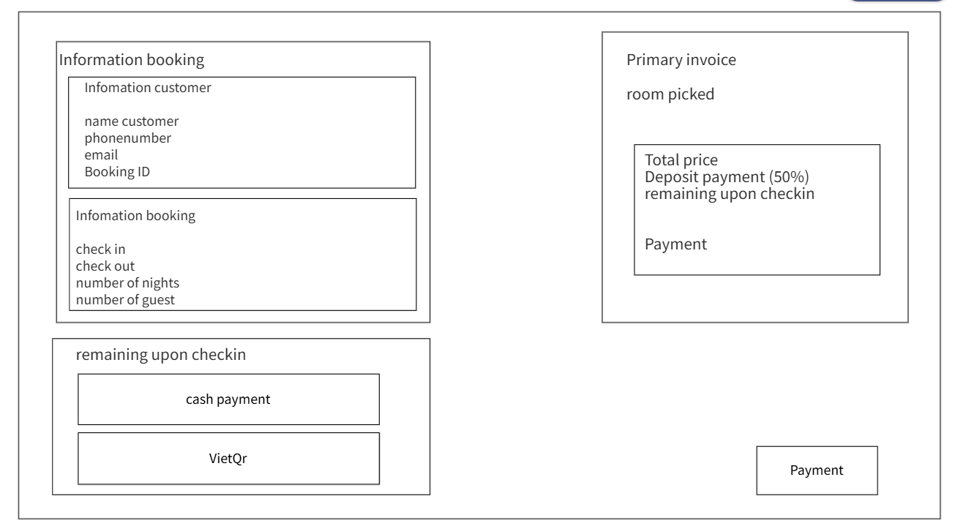

12.Revenue Report

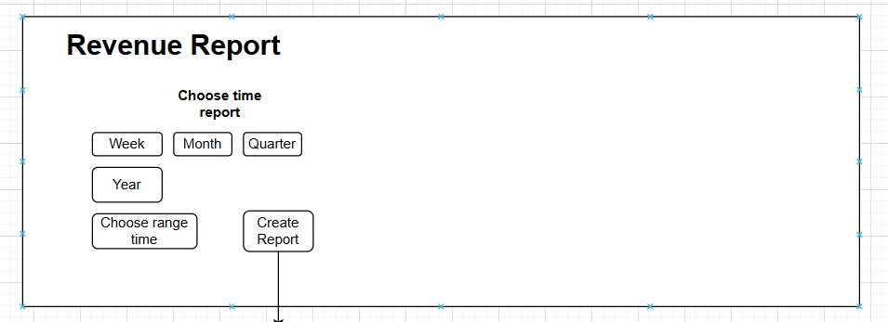
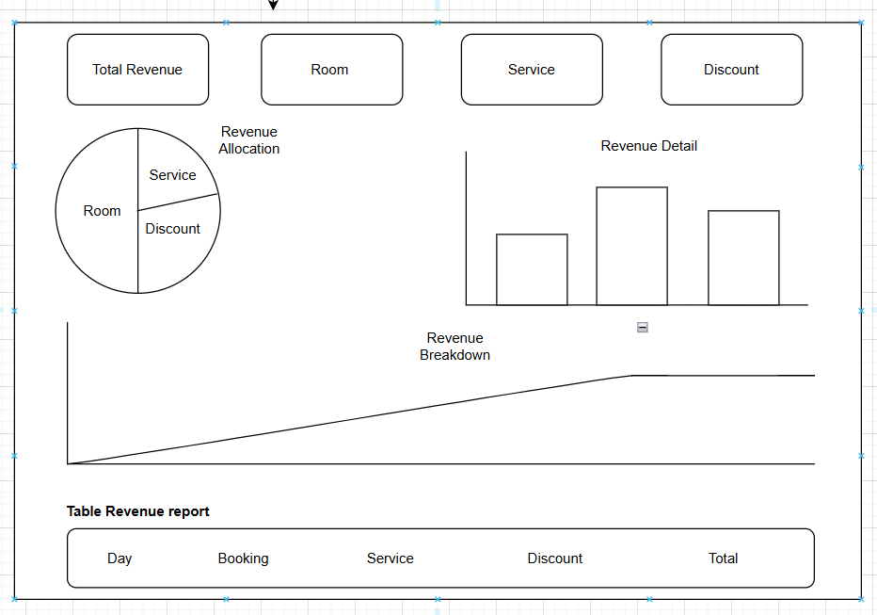

# | Field Name | Type | Mandatory | Max  Length | Description
1 | Week | Button | Yes | N/A | Choose week to create report
2 | Month | Button | Yes | N/A | Choose month to create report
3 | Quarter | Button | Yes | N/A | Choose Quarter to create Quarter
4 | Choose range time | Dropdown | Yes | N/A | Choose tange time you want to show revenue
5 | Create Report | Button | Yes | N/A | Generate reports by time period as selected by admin
6 | Total Revenue | Number | No | N/A | Show total revenue
7 | Booking | Number | No | N/A | Show booking room revenue
8 | Service | Number | No | N/A | Show service revenue
9 | Promotion | Number | No | N/A | Show promo code value

Item | Details
UC ID and Name | UC 46 - Revenue Report
Created By | Pham Nguyen
Created Date | 26/07/2025
Primary Actor | Admin
Secondary Actor | None
Trigger | The admin wants to view revenue report
Description | The system allows users to generate revenue reports based on a specific selected time period.
Preconditions | 1. The admin is logged in to the system.  2. The system display Revenue report
Postconditions | - The promotion information is updated in the system.  - The updated promotion appears in the promotions list.
Normal Flow | 1.0: View revenue Week  - The admin clicks the button “Revenue Report”.  - The system displays the revenue page.  - The admin selected Week  - The admin clicks the "Create Report" button.  - The system displays a revenue detail for week
Alternative Flow | 1.1: View revenue Month  - the admin clicks the "Month" button.  - The admin selects “ Month” and wants to show a report.  - The admin clicks the button “Create Report”.  - The system shows all revenue for the month.
Exception Flow | If the user does not select a time period or year, the system will not allow clicking the button to create a report.
Priority | Medium to High
Business Rules | BR01: User must select at least a time period (Week, Month, Quarter) and year before generating the report.  BR02: If "Week" is selected, user must select a specific week within the selected year.  BR03: If there is no data for one or more items (Total Revenue, Orders, Services, Promotions), the system will display "0 VND" for that item.

Field Name | Type | Mandatory | Max Length | Description
Information booking | Label | No | N/A | Label for the booking information section.
Information customer | Label | No | N/A | Label for the customer information subsection.
name customer | Text Input | No | N/A | Input field for the customer's name.
phonenumber | Text Input | No | N/A | Input field for the customer's phone number.
email | Text Input | No | N/A | Input field for the customer's email.
Booking ID | Text Input | No | N/A | Input field for the booking identification number.
check in | Text Input | No | N/A | Input field for the check-in date.
check out | Text Input | No | N/A | Input field for the check-out date.
number of nights | Text Input | No | N/A | Input field for the number of nights.
number of guest | Text Input | No | N/A | Input field for the number of guests.
Primary invoice | Label | No | N/A | Label for the primary invoice section.
room picked | Text Display | No | N/A | Display field for the selected room.
Total price | Text Display | No | N/A | Display field for the total price.
Deposit payment (50%) | Text Display | No | N/A | Display field for the deposit amount (50% of total).
remaining upon check-in | Text Display | No | N/A | Display field for the remaining amount due upon check-in.
Payment | Label | No | N/A | Label for the payment section.
cash payment | Button | No | N/A | Button for selecting cash payment method.
VietQR | Button | No | N/A | Button for selecting VietQR payment method.
Payment (Button) | Button | No | N/A | Button to confirm the payment.

13. Manage invoice

13.1. Invoice review page

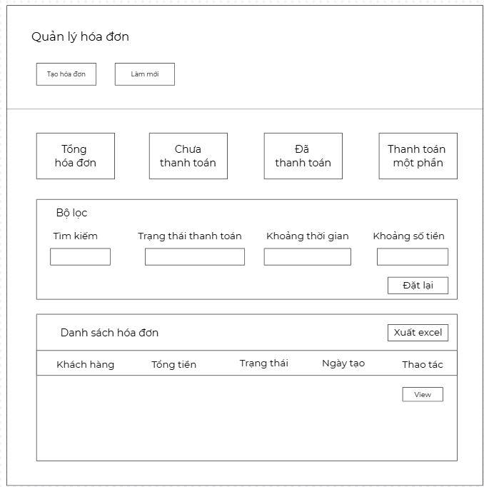

Field name | type | mandatory | Max  length | description
CustomerName | String | yes | 100 | Full name of the customer
TotalAmount | Int | yes |  | Total amount of the invoice in local currency (VND)
paymentStatus | String | yes |  | Status of the payment (paid, unpaid, or partially paid)
CreateAt | Date | yes |  | Date and time when the invoice was created
Action | button | no |  | Action buttons view

Item | Detail
Use Case ID | UC- 47
Use Case Name | Manage invoice
Create By | Le Tran Trong Dat
Create Date | 30/06/2025
Actor | Admin / Receptionist
Description | The actor can view, search, filter, create, and export invoices.
Precondition | The user must be logged in with appropriate permissions.
Postconditions | Invoices are displayed, filtered, created, or exported successfully.
Normal flow | 1.The admin accesses the Invoice Management page.  2.The system displays the invoice list, filter options, and action buttons.  3.The user enters a search keyword.  4.The system filters and displays matching invoices.  5.The user applies filters: payment status, date range, amount range.  6.The system updates the invoice list based on the selected filters.  7.The user clicks the "Create Invoice" button.  8.The system displays the invoice creation form.  9.The user enters invoice information and clicks "Save".  10.The system validates input and saves the invoice.  11.The system returns to the invoice list and displays a success message.  12.The user clicks the "Export Excel" button.
Alternative flow | 1.If the user clicks the "Reset" button in filters, the system clears all filters and reloads the full list.  2.If the user clicks "Refresh", the system reloads the invoice list without resetting filters.  3.If the user does not enter any filters, the system shows all invoices by default.
Exception Flow | 1.If the user enters an invalid date format, the system shows: “Invalid date format.”  2.If no invoices match the filter criteria, the system shows: “No invoices found.”  3.If the server fails to fetch invoice data, the system shows: “System error. Please try again.”
Business Rules | 1.Only Admins/Receptionists can manage invoices.  2.Exported files follow standard Excel format.

13.2. View invoice
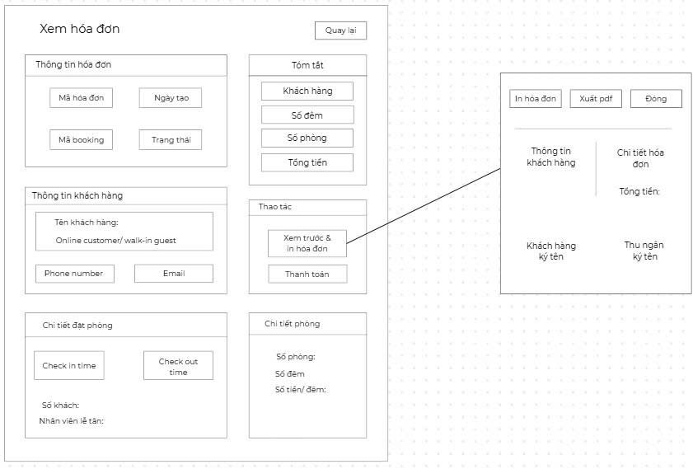

Field name | type | mandatory | Max  length | description
Invoice ID | Int | yes | 100 | ID Invoice
Date Created | Date | yes | 100 | Date Created Invoice
Booking ID | Int | yes | 100 | Booking id
Status | text | yes | 100 | Payment status
Name customer | Text | yes | 100 | Name customer
Phone number | Number | yes | 100 | Phone number
Email | Email | yes | 100 | Email customer
Check in time | Date | yes | 100 | Date of checkin
Check out time | Date | yes | 100 | Date of checkout
Number person | Number | yes | 100 | Number customer checkin
Receptionist | Text | yes | 100 | name of receptionist who receives room booking
Number of nights | Numbers | yes | 100 | Number of nights the customer rented the room
Number of room | Numbers | yes | 100 | Action buttons view
Total Amount | Number | yes | 100 | Number of rooms rented by customers
Preview Invoice | Button | yes | N/A | preview bill
Pay | Button | yes | N/A | Pay Invoice
Print Invoice | Button | No | N/A | Print invoice
Export PDF | Button | No | N/A | Print pdf
Close | Button | No | N/A | Close preview
Back | Button | No | N/A | Back to booking

Field name | type | mandatory | Max  length | description
CustomerName | String | yes | 100 | Full name of the customer
TotalAmount | Int | yes |  | Total amount of the invoice in local currency (VND)
paymentStatus | String | yes |  | Status of the payment (paid, unpaid, or partially paid)
CreateAt | Date | yes |  | Date and time when the invoice was created
Action | button | no |  | Action buttons view

Item | Detail
Use Case ID | UC- 48
Use Case Name | View Invoice
Actor | Receptionist
Description | The actor can preview, pay, print invoice, export pdf
Precondition | The user must be logged in with appropriate permissions.
Postconditions | Invoices are displayed exactly for information booking.
Normal flow | 1.The actor accesses the Invoice Management page.  2.The system displays the invoice list, filter options, and action buttons.  3.The user enters a view invoice.  4.The user checks all information booking.  5.The Actor payment confirmation for successful customer payment.  6.The Receptionist clicks “Payment confirm”.
Alternative flow | AF1.If the customer want to pay with bank transaction receptionist will show QRCODE  AF2.The system displays payment success.  AF3. The receptionist confirmed that the customer had paid successfully.
Exception Flow | 1.If the receptionist enters wrong information invoice will be canceled
Business Rules | BR1.Only Admins/Receptionists can manage invoices.  BR2.Only confirm successful payment when the customer has made a transaction.

13.2. Export Invoice to PDF

Item | Details
UC ID and Name | UC 46 -Export Invoice to PDF
Created By | Le Tran Trong Dat
Created Date | 25/07/2025
Primary Actor | Admin
Secondary Actor | Receptionist
Trigger | The user clicks the "Export to PDF" button on a specific invoice.
Description | This use case allows the user to export an invoice as a downloadable PDF file.
Preconditions | - The user is logged in.  - The selected invoice exists.  - The user has permission to export invoice data.
Postconditions | A PDF version of the selected invoice is generated and downloaded..
Normal Flow | 1.The user navigates to the Invoice Management page.  2.The system displays a list of invoices.  3.The receptionist clicks the "Export to PDF" button next to a specific invoice.  4.The system generates a PDF document of the selected invoice.  5.The PDF is downloaded automatically or the browser prompts the user to save it.
Alternative Flow | The user selects multiple invoices and clicks "Export All to PDF" → System compresses multiple PDF files into a ZIP and downloads it.
Exception Flow | 1. Invoice data is missing or corrupted → System displays: “Cannot generate PDF: Incomplete data.”  2.Export service fails → System displays: “Failed to generate PDF. Try again later.”
Priority | Medium to High
Business Rules | BR01: Only authorized users can export invoices.  BR02: The exported PDF must match the system invoice format and include all mandatory fields.

III. System Design

1. Database Design

1.1 Entity-Relationship Diagram

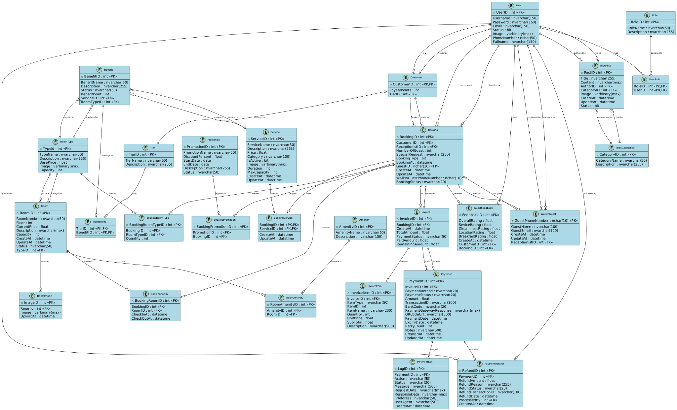

1.2 Table Descriptions

No | Table | Description | Attributes
1 | AdminApprovalLog | Stores admin approval logs for rooms. | approvalID (PK), Pid (FK), Action,  Status, Detail, Decider (FK), Date, pName
2 | Amenity | List of available amenities in the hotel. | AmenityID (PK), AmenityName, Description
3 | BlogCategories | Categories for blog posts. | category_id (PK), category_name, description
4 | BlogImages | Images related to blog posts. | image_id (PK), post_id (FK),  image_url, uploaded_at
5 | BlogPosts | Blog posts of the hotel. | post_id (PK), title, content,  author_id (FK), category_id (FK),  image, created_at, updated_at, status
6 | BookingPromotion | Junction table linking bookings and promotions (many-to-many relationship). | PromotionID (PK, FK), BookingId  (PK, FK)
7 | Booking | Booking details for rooms, customers, and services. | BookingID (PK), CustomerID (FK), ReceptionistID (FK), Status,  BookingDate, CheckInDate, CheckOutDate, TotalAmount, PaymentStatus
8 | BookingRoom | Junction table between bookings and rooms. | BookingID (PK, FK), RoomID  (PK, FK), CreatedAt
9 | Customer | Registered customers who can make bookings. | UserID (PK, FK), LoyaltyPoint
10 | Feature | List of system features for role-based access. | FeatureId (PK), FeatureName
11 | GuestFeedback | Feedback provided by guests after their stay. | FeedbackID (PK), Rating, Comment, CreatedAt, BookingID (FK)
12 | Invoice | Invoice details generated for each booking. | InvoiceID (PK), BookingID (FK), CreatedAt, TotalAmount,  PaymentStatus
13 | Promotion | Hotel promotions that can be applied to bookings. | PromotionID (PK), PromotionName, Discount, StartDate, EndDate,  Description
14 | Receptionist | Staff members responsible for handling bookings. | UserID (PK, FK)
15 | Role | System roles for access control. | RoleID (PK), RoleName, Description
16 | Room | List of rooms available in the hotel. | RoomID (PK), RoomNumber, Floor, RoomTypeID (FK), Status, Description
17 | RoomAmenity | Junction table mapping rooms to amenities. | RoomID (PK, FK), AmenityID (PK, FK), Quantity
18 | Rooming | Historical log of room availability status. | RoomingID (PK), RoomID (FK), BookingID (FK), CheckInDate, CheckOutDate
19 | RoomType | Room categories/types like Deluxe, Suite, etc. | TypeID (PK), TypeName, Description, BasePrice
20 | Service | Additional services offered by the hotel. | ServiceID (PK), ServiceName, Description, Price
21 | BookingService | Junction table between bookings and services. | BookingID (PK, FK), ServiceID  (PK, FK), CreatedAt
22 | User | System users including customers, admins, staff, etc. | UserID (PK), FullName, Email, Phone, PasswordHash, Gender, DOB,  CreatedAt, RoleID (FK)
23 | UserRole | Junction table for assigning multiple roles to a user. | RoleID (PK, FK), UserID (PK, FK)
24 | RoleFeature | Junction table mapping roles to features (permissions). | RoleID (PK, FK), FeatureId (PK, FK)
25 | VisitorGuest | Guests not registered as customers (walk-in). | GuestID (PK), FullName, Phone, CreatedAt, DOB
26 | WalkInGuest | Booking by walk-in guests (linked to VisitorGuest). | GuestID (PK, FK), Feature, BookingID (FK), Date

